

**FLEET SAFETY**

# What does fleet safety mean to Hanson?

Hanson has operations and vehicles in all Australian states. This paper focuses on what Hanson has done and is doing to improve the safety of its road fleet, the drivers of those vehicles and the general public as the Hanson vehicles and drivers interact with the general population either on roads or sites.

The Hanson operation also includes the Hymix plants and fleet.

This paper looks briefly at various safety programs and initiatives that relate to road transport and well as general business and management procedures that relate to road transport.

Fleet safety to Hanson means providing our drivers with properly specified equipment capable of performing the task asked of it, maintaining that equipment to a safe standard and providing drivers and the people that influence them with the necessary knowledge, awareness and training to safely perform their duties and return home safely.

# Heavy Fleet

The Hanson heavy vehicle fleet in Australia comprises some 370 tippers, 20 tankers and 1180 agitators. The tipper fleet includes rigid trucks, truck and dog combinations, semi-trailers, B doubles and pocket road trains. The agitator fleet includes mini trucks, 3 axle rigid trucks, 4 axle rigid trucks and semi-trailers.

The Hanson fleet includes 1060 company trucks and over 500 contracted owner drivers. This fleet is augmented by use of casual sub-contractors during peak demand.

Hanson has 260 concrete plants and 56 quarries in Australia with operations in every state. Deliveries are made to a wide range of sites ranging from private customers own yards, council work, road construction sites, high rise developments, farms, dam sites to mine sites – including underground mines.

The Hanson approach to heavy vehicle fleet safety is aligned to the Chain of Responsibility regulations.

## Chain of Responsibility

CoR legislation deals with 4 main areas of road transport:

* Fatigue management
* Mass, dimension and load restraint
* Speeding compliance
* Dangerous goods

Hanson has developed a CoR management manual which deals with the responsibilities and duties of all persons who have a role in the Chain of Responsibility.

We have also been heavily involved in producing guidelines for the industry via the CCAA to raise awareness of the CoR regulations and what minimum actions member companies should be taking.

Hanson has recently rolled out a CoR training and awareness program across all operations. In NSW this involved a Compliance Manager visiting each site and training drivers, supervisors, batchers, weighbridge operators, sales loader drivers, allocators, schedulers and site managers on the CoR requirements, their responsibilities and duties. This program highlighted to each person what role they play in the CoR and what responsible steps they must take to ensure compliance. Equally importantly the program also addressed what each of the persons cannot do or what they cannot instruct another person to do.

This program was recently awarded an Industry Award at the recent NSW Environment, Health & Safety Awards night held by Cement Concrete and Aggregates Australia

Hanson has offered all CCAA members free access to this training program including copies of all presentations and supporting documentation.

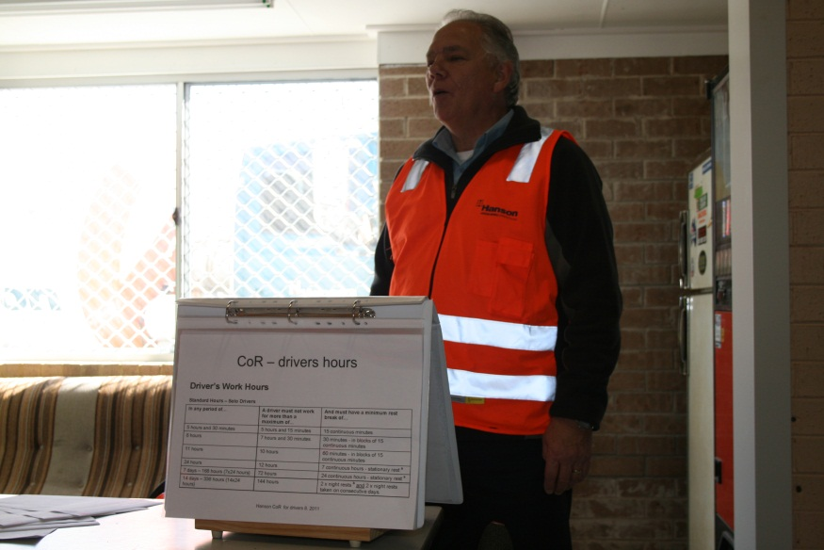

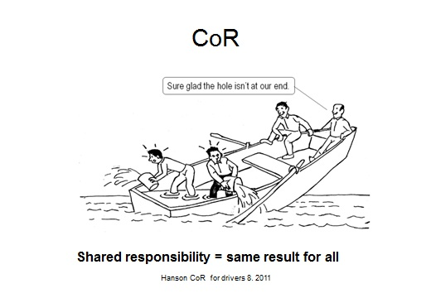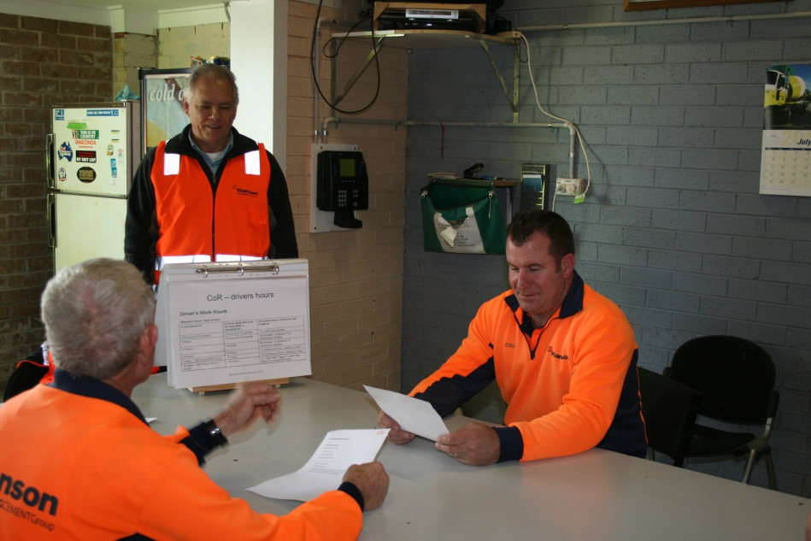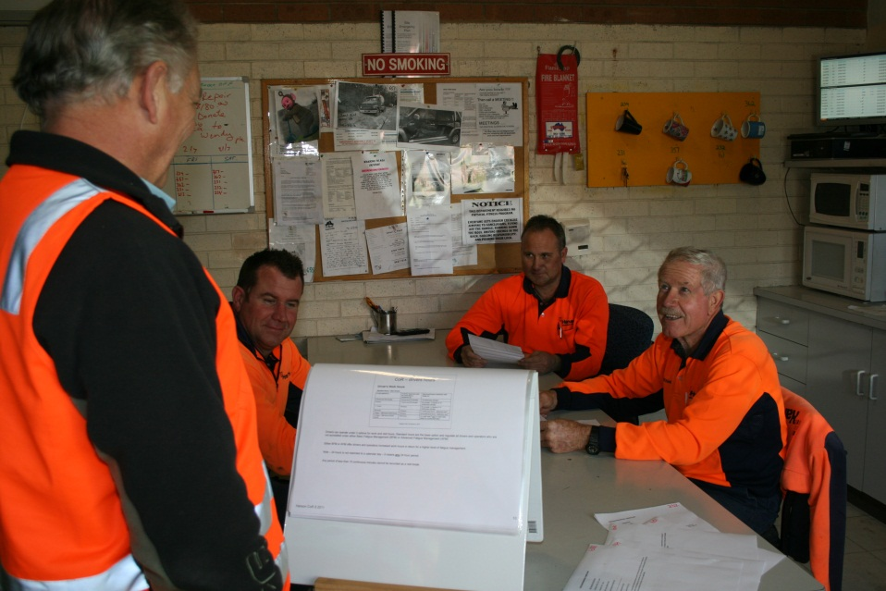

C:\Users\williamss\Documents\chain of responsibility\quarry sign CoR.TIF



*Documentation – Hanson CoR Management Manual; Hanson CoR for Drivers; Hanson CoR for Batchers, Weighbridge Operators and Sales Loader Drivers; Hanson CoR for Managers and Supervisors.*

## NHVAS

The National Heavy Vehicle Accreditation Scheme (NHVAS) is a voluntary alternative to conventional heavy vehicle enforcement. Accredited operators must demonstrate that their vehicles and drivers comply with standards set by the National Heavy Vehicle Accreditation Scheme through regular audits of their transport management systems and vehicle or driver assessments. The National Heavy Vehicle Accreditation Scheme is intended to increase transport efficiency by reducing the costs of compliance and allowing members greater flexibility in the management of their transport business.   
  
The objectives of the mass and maintenance management modules are to:

* improve efficiency for scheme members by reducing the impact of conventional regulatory enforcement
* raise levels of compliance for non-accredited operators through more effective deployment of enforcement resources
* improve road safety
* increase the productivity of the transport industry through adoption of 'good' management practices
* allow higher mass limits to be introduced in a responsible way.

Hanson company trucks based in NT, Queensland, NSW, SA, Victoria and Tasmania are accredited in Mass Management and Maintenance Management with the NSW RMS.

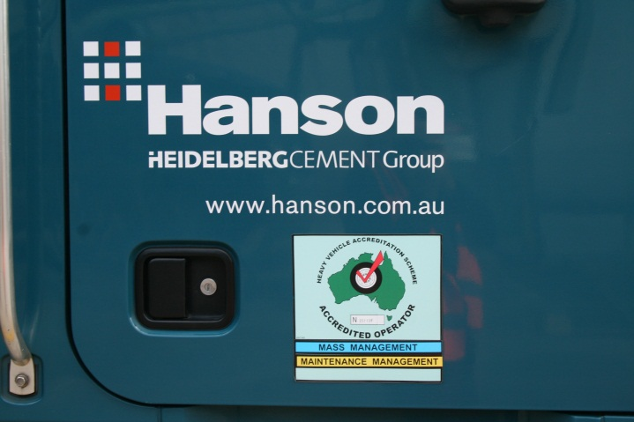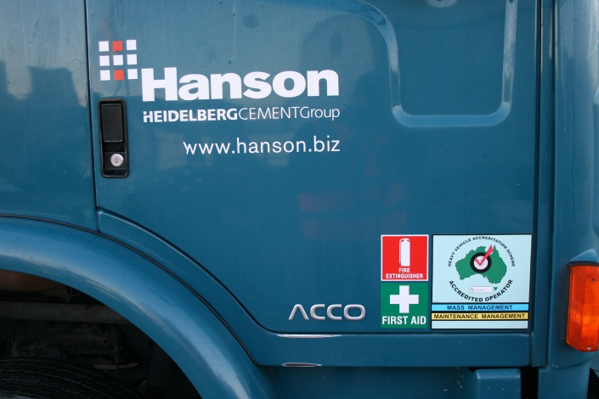

### Maintenance Management

The principle is to ensure that all maintenance of heavy vehicles is to at least the manufacturers’ standards and requirements and that vehicles are regularly checked and all faults rectified.

This module demands 9 standards to be met.

1. Daily documentation of roadworthiness checks undertaken.
2. Provision for vehicle fault recording and reporting.
3. Identification, assessment and action on reported vehicle faults.
4. Periodic maintenance schedules with identified service periods that describe all tasks to be completed.
5. Documented evidence maintained to demonstrate the effective operation of Maintenance Management Standards.
6. Clearly defined authority, responsibility and duties of all positions involved in the management, operation, administration, participation and verification of the Maintenance Management System.
7. Internal review to be completed every 12 months to verify that all results and activities comply with the systems policies, procedures and instructions.
8. All persons with a position of responsibility (this includes drivers) are trained in and familiar with the specific policy procedure and instruction they are to carry out.
9. Fuel purchased for use in the vehicle must be obtained from a reputable supplier and measures must be taken to ensure that there is no fuel contamination.

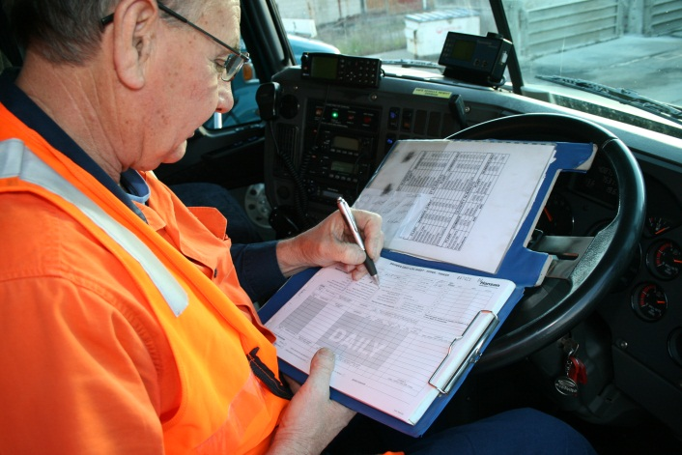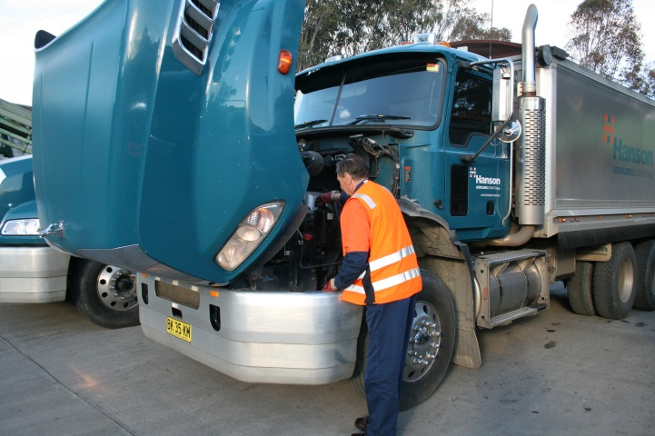

### Mass Management

The principle is to ensure that systems and checks are in place to ensure that all heavy vehicles are loaded up to the legally allowable mass only

This module demands that 8 standards be met.

1. Clearly defined authority, responsibility and duties of all positions involved in the management, operation, administration, participation and verification of the Mass Management System.
2. All vehicles nominated by the accredited operator must be operated in accordance with the Mass Management System
3. Vehicle mass must be determined prior to departure allowing for any variation
4. Documented evidence must be maintained to demonstrate the effective operation of the Mass Management System.
5. The weight of the vehicle and load must be verified to produce an auditable record.
6. Internal review to be completed every 12 months to verify that all results and activities comply with the systems policies, procedures and instructions.
7. All persons with a position of responsibility (this includes drivers) are trained in and familiar with the specific policy procedure and instruction that they are to carry out.
8. All vehicles subject to accreditation must have their suspension systems maintained and replaced according to Manufacturers’ specification and taking into account the ARTSA Air Suspension Code.



*Documentation – NHVAS Hanson Maintenance Management System Manual; NHVAS Hanson Mass Management System Manual; NHVAS Driver Training*

## Specification

Heavy vehicles specification has been established and is reviewed regularly by the Logistics Managers to ensure that the heavy vehicle can perform the allocated task safely and efficiently.

Current tipper and tanker specification includes Front Under-run Protection.

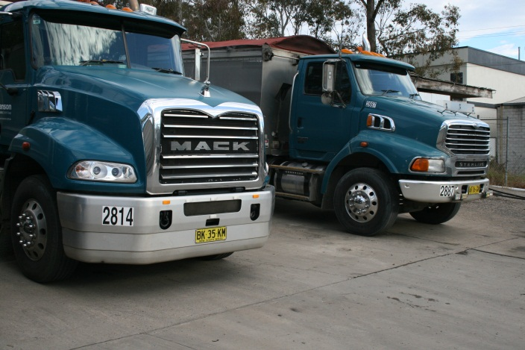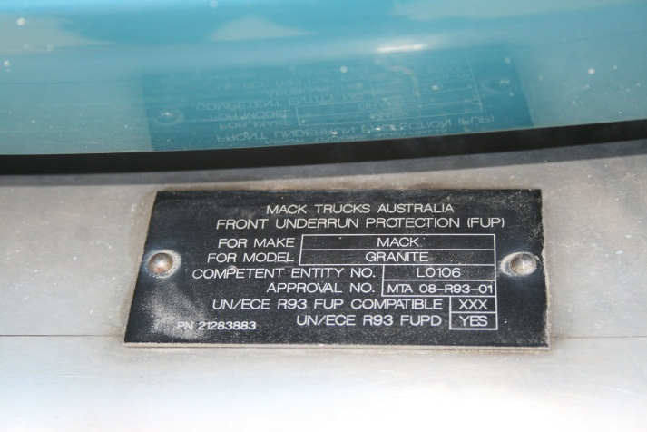

*Truck on left has FUPS front bar FUPS certification plate*

Maxi brake alarms fitted to all heavy vehicles – if driver’s door is opened and maxi brake (park brake) is not applied then horn will sound.

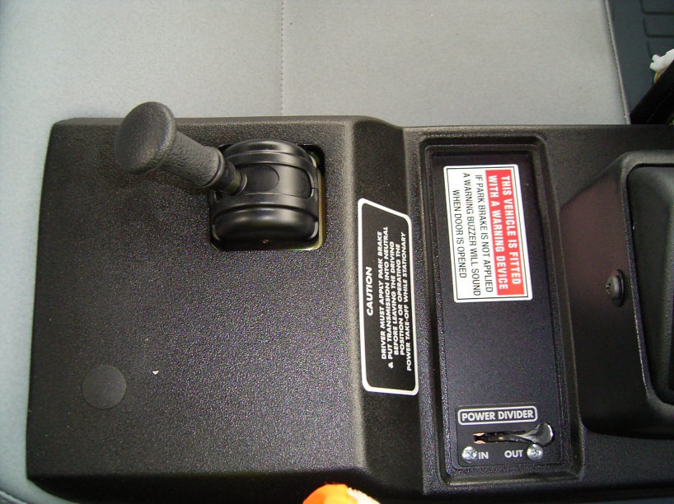

All 4 axle rigid trucks fitted with maxi brakes to 3 axles – now adopted by Mack as standard specification.

Rear access steps fitted to agitators. Ladders are deleted option.

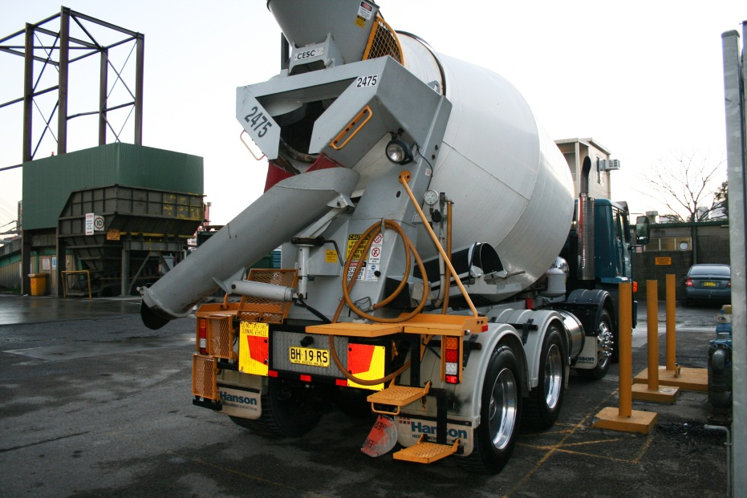

All tippers fitted with motorised tarps and spray suppression brushes.

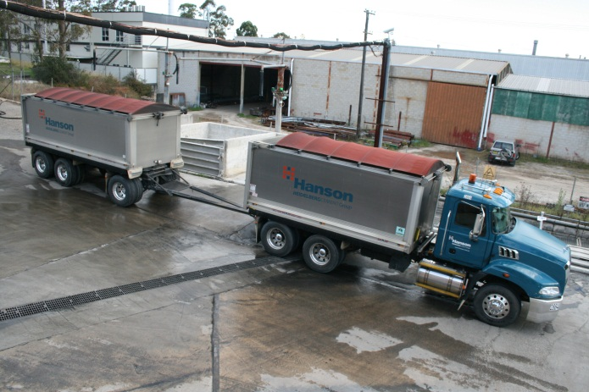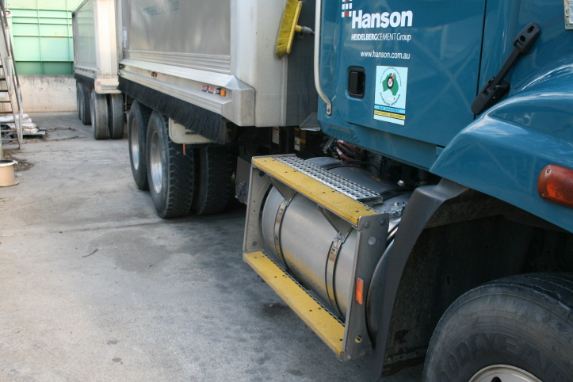

Developing integrated GPS and monitoring system linked to SAP and TeSys (allocation system) to track vehicle location, speed and status and driver’s work and rest hours. Heavy vehicles currently fitted with Tacholink truck logging system.

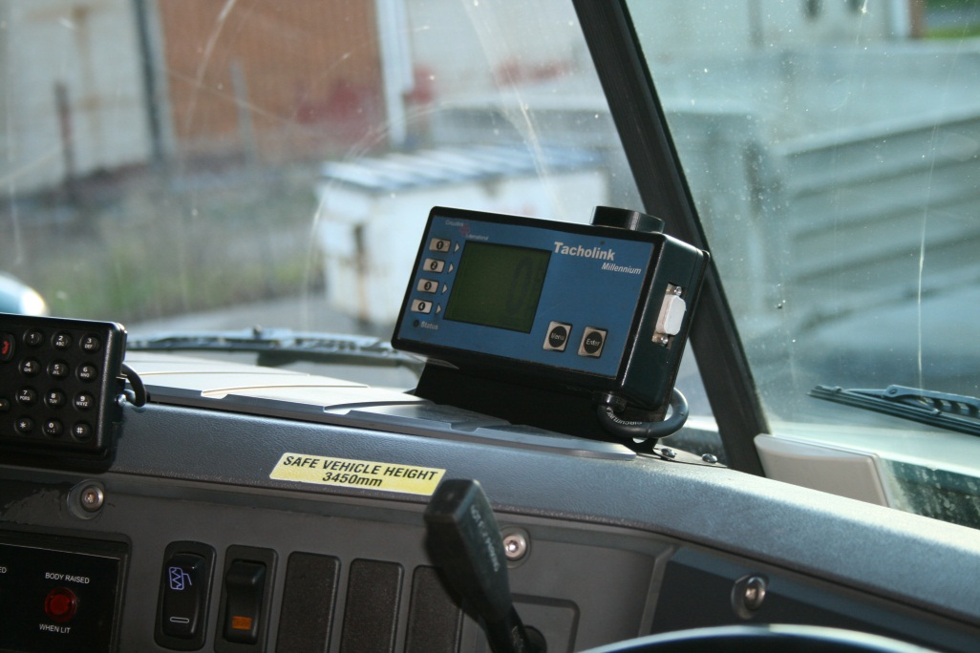

The Hanson tipper fleet is one of the few fleets in the industry to specify disc brakes on trucks and trailers.

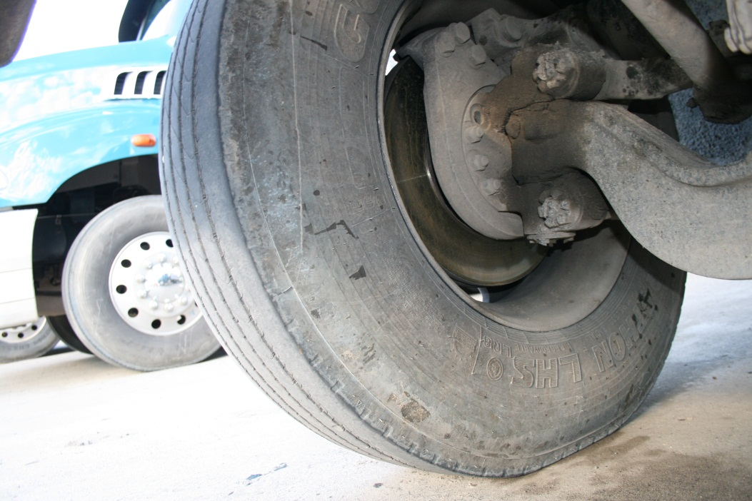

Selection of safety signage and messages.

## 

 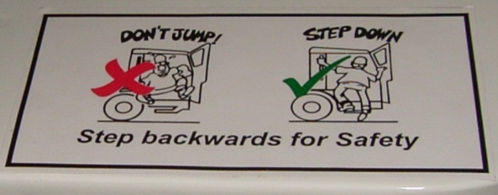

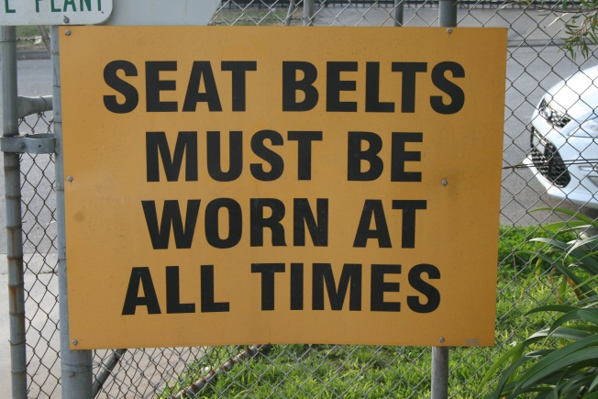 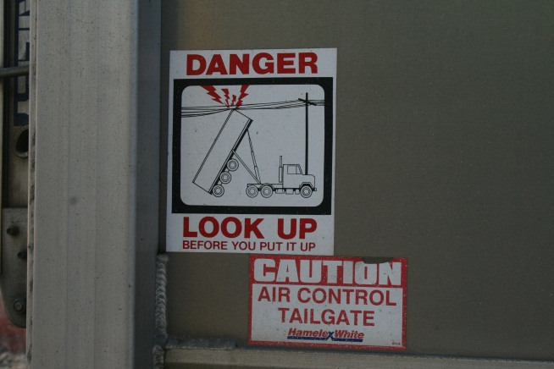

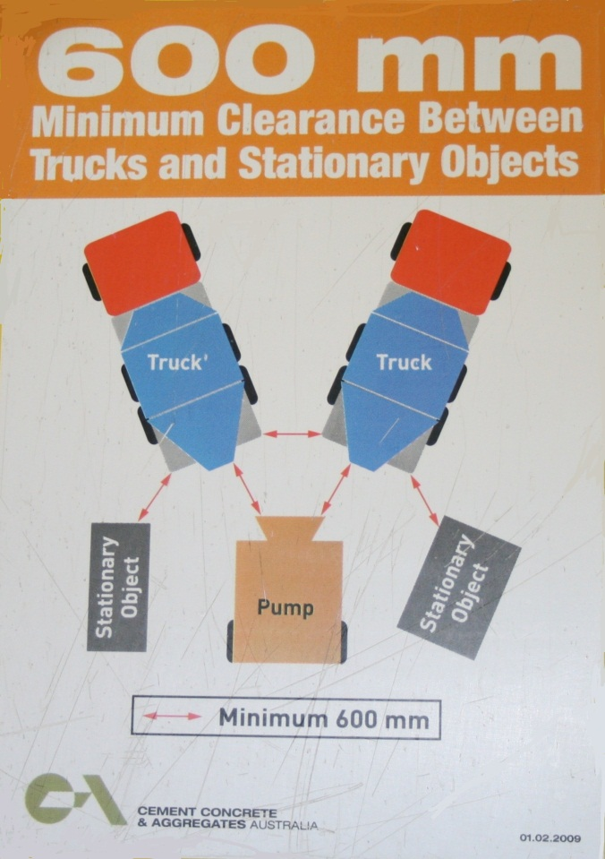

## Drivers

### Selection

Driver applicants must pass a pre-employment driving test conducted. Drivers must be medically fit as per the Standards for a Commercial Heavy Vehicle Driver. All employees undergo random drug and Alcohol testing as per the Fitness for Duty Program.

Drivers must possess a current Australian licence for the class of vehicle that they operate.

*Documentation – Hanson pre-employment driving test; Hanson Fitness for Duty Program*

### Training

New drivers undergo training on the job with experienced drivers before being allocated a vehicle.

In conjunction with the CCAA, an industry standard approach to driver training is being developed. An industry standard set of modules and competencies are being developed for inclusion in a Certificate 3 course outline.

Drivers must be deemed competent for each type of vehicle that they drive. A driver wishing to move to a larger truck must undertake training and demonstrate competency in the operation of that vehicle before he or she is assigned to that class of vehicle.

*Documentation – Concrete Truck Driver Training Program*

### Assessment

Drivers are assessed annually by their direct manager – topics include driver attitude to road safety and safety initiatives.

*Documentation – Hanson Driver development review; Agitator Driver Assessment*

# Light Vehicles

The Hanson light vehicle fleet comprises some 340 passenger vehicles, 310 utes both 2WD & 4WD, 56 4WD wagons and 5 light trucks.

The light vehicle fleet is also spread across all states in Australia

## Specification

The following equipment is to be installed on all Company passenger vehicles:

* Anti-lock braking system,
* Vehicle stability control
* Driver’s and passenger's front airbag
* Air conditioning
* Automatic transmission
* Floor mats
* Mud flaps (where applicable)
* Metallic paint
* Tinted windows
* Cargo barrier (wagon only)
* Rear parking sensors or rear camera.

A first-aid kit is to be carried in all Company vehicles.

In addition to this list the standard tool of trade passenger vehicle that is offered to employees includes full length side curtain air bags.

The following equipment is to be installed on all Company utility and 4WD vehicles:

* Anti-lock braking system,
* Driver’s and passenger's front airbag
* Air conditioning
* Floor mats
* Mud flaps (where applicable)
* Tinted windows

In addition any vehicle used in a quarry must have a two way radio, flashing warning light and high level flag.

## Driver Training

*Documentation – Car Driver’s Handbook*

## Vehicle Maintenance

All light vehicles are serviced to the manufacturers log book services either by a Dealer or by a service provider who meets the standards set by the national procurement team.

# Other Safety Initiatives

Hanson has other safety programs and initiatives underway, whilst not solely aimed at Fleet Safety do enhance fleet safety or the safety of other road users.

## Internal Initiatives

### Zero Harm

Concept focus is on people experiencing Zero Harm whilst at work and “Mates Helping Mates.”

Encompasses vehicle access, and driver behaviour in and around vehicles.

### Tool box meetings

### Safety Alerts

## External Initiatives

### Wolffdene Quarry and Rivermount College

A local initiative involving a local college and raising the students awareness regarding sharing the road with heavy vehicles.

|  |  |  |  |
| --- | --- | --- | --- |
| |  |  |  | | --- | --- | --- | | Wolffdene quarry offers schoolers rock solid career | [Minimize](javascript:__doPostBack('dnn$ctr2044$dnnVISIBILITY$cmdVisibility','')) |  | |
| http://www.hanson.com.au/Portals/_default/Containers/Hanson/images/spacer.gif |
|  |
|  |
| Three Hanson employees from Wolffdene Quarry recently presented a special workshop at the local Rivermount College to help raise awareness and educate local young drivers about trucks and cars safely coexisting on roads.  Around 80 year 11 and 12 Rivermount College students took part in the interactive presentation and workshop held at the school and facilitated by Wolffdene Quarry manager Reno Fabretto, South East transport manager Hayden Post and South East Queensland driver trainer Allan Bennett.  The forward-thinking presentation focused on educating the students and future P Platers about safely driving around trucks and teaching the students about how trucks operate. Wolffdene Quarry’s Reno Fabretto said the local team came up with the idea for the presentation after seeing a number of near misses on the roads surrounding the quarry.  “As part of our community focus, we realised we needed to widen our scope and spread the safety messages with young adults to ensure our local roads are safe,” Mr Fabretto said.  “The presentation went really well and we hope to roll this out every year and branch out and include other surrounding schools.”  “We were a little nervous going into the presentation as it has been a long time since any of us have been back in a school room.”  “The students were so taken by what we had to say, particularly with Allan’s firsthand experiences as a young lad and life on the road,” he said.  “When Allan and Hayden were talking about the near misses and how quickly a wrong decision could become fatal, you couldn’t hear a pin drop. We had 80 ears and eyes directed at us really taking in what we had to say.”  “We had so many students come up to us afterwards and ask questions about what quarries do, why we need quarries, how to become a truck driver and questions about the trucks. It was a great way to interact with the next generation and also break down barriers about quarries and truck drivers in the community.”  The workshop looked at what it takes to drive trucks; break down myths about trucks and truck drivers; show the ins and outs of a truck regarding blind spots and visibility on the road; and most importantly, discuss the key issues when driving around trucks such as overtaking, braking and tailgating.  Prior to the presentation, Hayden, Allan and Reno had set up a haulage truck in the school car park and a sedan vehicle to demonstrate blind spots and visibility while on the road. Each student accessed the cabin of the truck and was given a one-on-one tour and demonstration of life as a truck driver.  The local newspaper, Albert and Logan News, reported the presentation and took a photo with the students with Reno looking over the truck. The story will also run in the school newsletter and the workshop notes will be uploaded on to the school’s intranet for parents and wider community to share in the presentation.  “As part of our presentation, we provided some real life stories about life on the roads,” Mr Fabretto said.  “While there were plenty of laughs (mainly at Allan), there were some serious moments where we provided the young drivers with some safety tips and hints for when they eventually get behind the wheel. The whole process was about educating and working together.”  Rivermount College Principal Richard Young congratulated Wolffdene Quarry for taking this forward-thinking step.  “Staff and students at Rivermount College were eagerly looking forward to this presentation and we look forward to seeing the Hanson team again next year,” Mr Young said.  Wolffdene Quarry and Rivermount College have a long history of working together. Wolffdene Quarry provided materials for when the school was first constructed and continues to work with the school in regards to school tours, science studies and job traineeship programs. |

