Tweets and Graphics

Below are two suggested tweets for each campaign day and one image per day designed to go with the second tweet.

Monday

Many drivers admit THEY engage in the behaviors they find unacceptable in others. It’s Drive Safely Work Week. How’s your driving? #DSWW2016

Driver behavior contributes to 94% of all crashes. YOUR DECISIONS DRIVE YOUR SAFETY. #DSWW2016
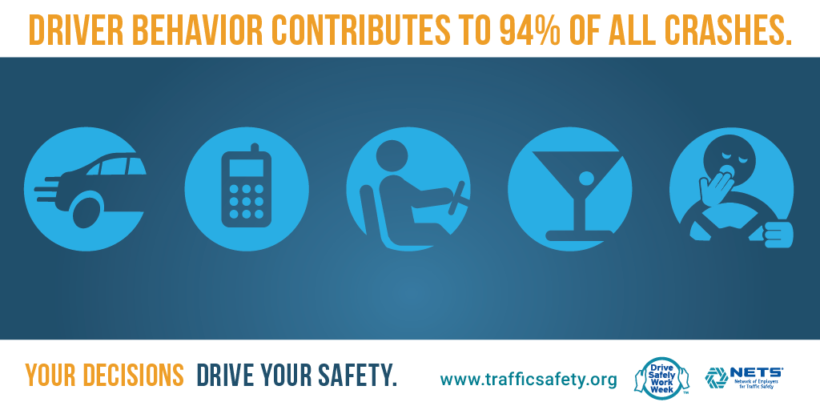

Tuesday

Good sleep drives positive behavior and performance in all things. Work, relationships, athletics, driving safely. #DSWW2016

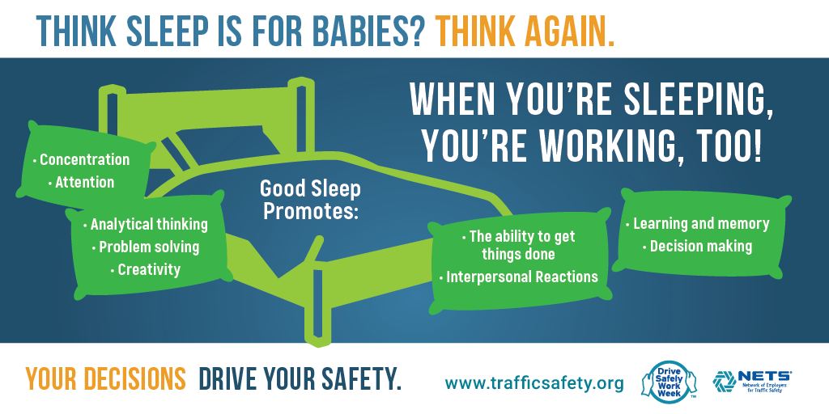
Think sleep is for babies? Think again. When you’re sleeping, you’re working, too! #DSWW2016
Wednesday

Feeling drowsy while driving? The only true countermeasure is to pull over and take a break. YOUR DECISIONS DRIVE YOUR SAFETY. #DSWW2016

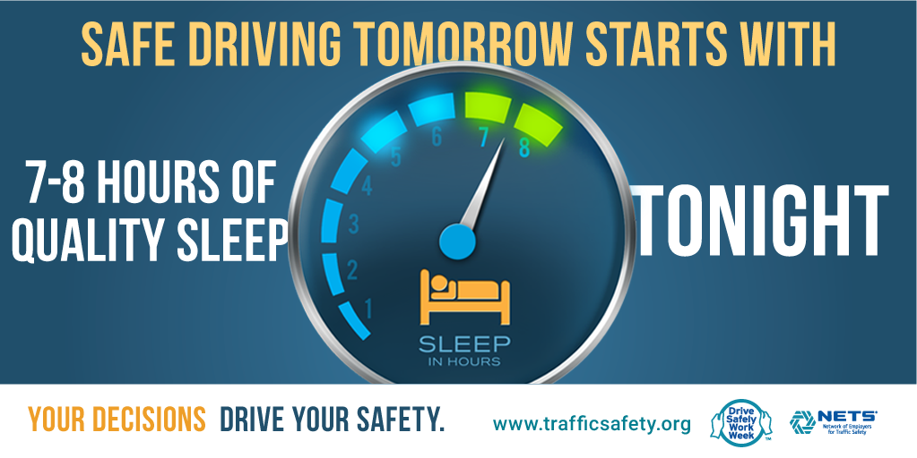
Safe driving tomorrow starts with 7-8 hours of quality sleep tonight. YOUR DECISIONS DRIVE YOUR SAFETY. #DSWW2016

Thursday

Help others help themselves. Never text or call if u know they’re driving. YOUR decisions could help drive THEIR safety. #DSWW2016

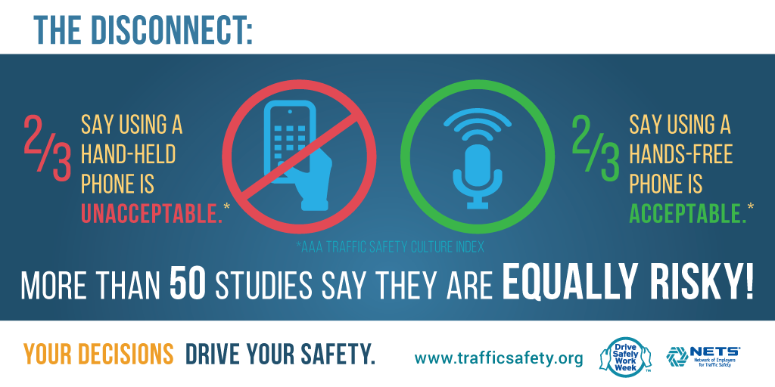
Handheld or Hands-free, they are equally risky. Silence and stow before you go. #DSWW2016

Friday

Don’t put your safety in the hands of other drivers. Buckle up on every trip. Every time. YOUR DECISIONS DRIVE YOUR SAFETY. #DSWW2016

There is a direct correlation between speed & crash severity. Life goes by too fast to NOT slow down. #DSWW2016
