NEWS FROM HERE & THERE 17 December 2013
SAFETY STARTS WITH ME – A HEALTHY SAFETY CULTURE
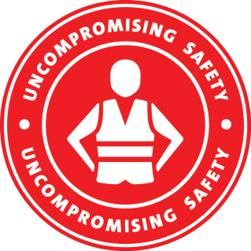
In an effort to make safety our number one priority we have all worked extremely hard at developing a solid safety culture resulting in a safety record we are proud of.
We all are encouraged to not only report safety incidents, but also to raise any concerns or ideas about safety to ensure our safety culture is an ongoing process that we strive to continually improve with an aim to go beyond simply satisfying legislative requirements.
A business with a healthy safety culture:
- Welcomes safety leadership at all levels of the business
- Conducts risk reviews and safety checks
- Makes positive changes to encourage new patterns of behaviour
- Clearly identifies safety aims and aspires to the best level of safety possible
- Communicates changes and safety messages to all staff
- Reports all near misses, incidents and accidents
- Learns from its mistakes and strives for the continuous improvement of its safety record
Director Safety, Quality & Risk, Rod Maule says: ’Our healthy safety culture includes the development of continuous improvements with all team members to ensure our safety performance continues to evolve. Communication, consultation and the celebration of successes are key to our safety culture. All team members should be consistently evaluating our safety culture and providing feedback.’
If you have any safety concerns or suggestions, please let your supervisor or safety representative know.

