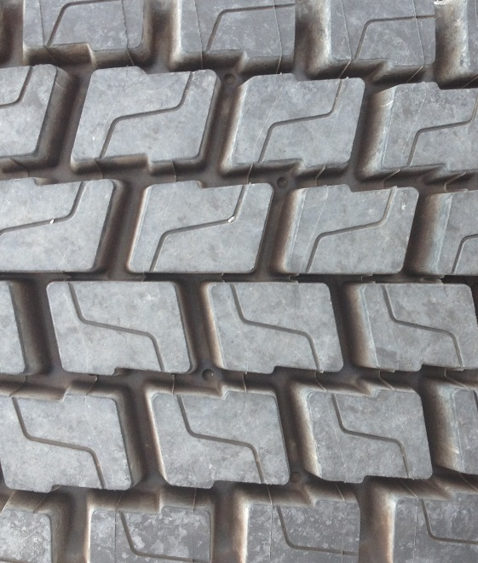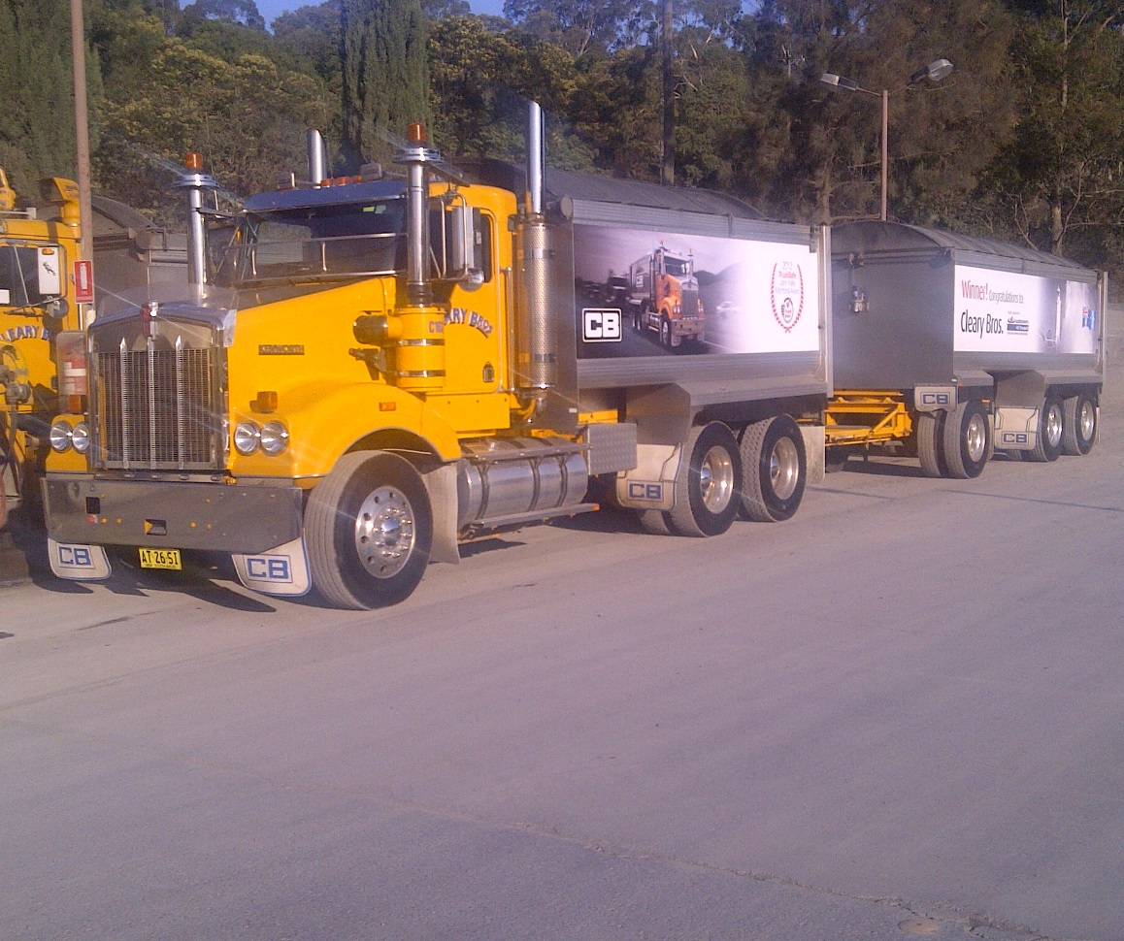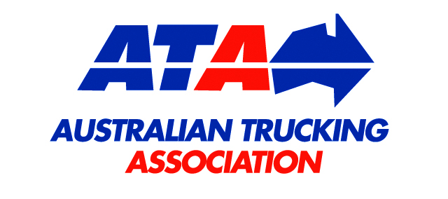

Developed by the ATA Industry Technical Council  
December 2015

Truck and dog trailer combinations

Technical  
Advisory  
Procedure

© 2008 Australian Trucking Association Ltd (first edition)

© 2015 Australian Trucking Association Ltd (second edition)

This work is copyright. Apart from uses permitted under the Copyright Act 1968, no part may be reproduced by any process without prior written permission from the Australian Trucking Association. Requests and inquiries concerning reproduction rights should be addressed to the Communications Manager, Australian Trucking Association, 25 National Circuit, Forrest ACT 2603 or [ata@truck.net.au](mailto:ata@truck.net.au).

**About this Technical Advisory Procedure (TAP):**

**This Technical Advisory Procedure is published by the Australian Trucking Association Ltd (ATA) to assist the road transport industry to improve the dynamic stability of truck and dog trailer combinations. The Technical Advisory Procedure has been drafted to apply to a range of truck and dog trailer combinations. It is not, nor is it intended to be, complete or without exceptions.**

**The Technical Advisory Procedure is a guide only, and its use is entirely voluntary. Recommendations or procedures may not be suitable for or applicable to all operators. Operators should consider their own circumstances, practices and procedures when using this Technical Advisory Procedure.**

**Operators must comply with the Australian Design Rules (ADRs), the Australian Vehicle Standards Regulations, roadworthiness guidelines and any specific information and instructions provided by manufacturers in relation to the vehicle systems and components.**

**No endorsement of products or services is made or intended. Brand names, where used in this Technical Advisory Procedure, are for illustrative purposes only.**

**Suggestions or comments about this Technical Advisory Procedure are welcome. Please write to the Industry Technical Council, Australian Trucking Association, Minter Ellison Building, 25 National Circuit, Forrest ACT 2603.**

**DISCLAIMER**

The ATA makes no representation and provides no warranty that the information and recommendations contained in this Technical Advisory Procedure are complete or without exception. Reliance or use upon the information or recommendations is voluntary and the user accepts all risks and responsibility for any such reliance or use and to the maximum extent permitted by law the ATA excludes all liability to any person arising directly or indirectly out of any such reliance or use.

**Introduction**

This Technical Advisory Procedure (TAP) has been developed by the ATA Industry Technical Council (ITC) to promote good design practices for truck and dog trailer configurations. It aims to do this by providing reliable information on important parameters relevant to dynamic performance. The TAP places particular emphasis on good design practice for achieving improved dynamic stability in truck and dog trailer combinations exceeding 42.5 tonnes Gross Combination Mass (GCM).

Truck and dog trailer combinations have been used in the road transport industry for more than 45 years. As axle weights and dimensions have increased, these combinations have evolved and the GCM of the various combinations increased. The GCM of rigid truck and dog trailer combinations varies from state to state and may range from 30 tonnes for an R11T11 to 67.5 tonnes for an R22T23. Assuming the axle spacing requirements are met, a 3 axle truck with a 3 axle dog has a maximum GCM of 45 tonnes in Victoria and 48 tonnes GCM in NSW.

With increasing gross combination mass, the dynamic stability of these larger combinations has been subject to the scrutiny of regulators and public comment.

The compliance approval process through the mechanism of the Australian Design Rules (ADR) results in the motor vehicle (the truck) and the towed vehicle (dog trailer) being assessed through two separate and independent approvals. This process then allows complying vehicle units to be coupled into a multi-vehicle combination within the mass and dimension limits as specified by the various state authorities.

In the mid-1990s, ARRB Transport Group was commissioned by the New South Wales Road Transport Authority (now RMS) to validate the performance of three and four axle dog trailers towed by three axle rigid trucks. This research used existing vehicle combinations and validated the performance of combinations up to 48 tonnes (six axles - R12T12) and 50 tonnes (seven axles – R12T22). Towed to towing mass ratios are 1:1.15 and 1:1.25 respectively for these combinations.

Later in the 1990s, following concerns raised by operators that were experiencing dynamic performance problems with some truck and dog trailer combinations in excess of 42.5 tonnes gross combination mass, the then NRTC (now NTC) embarked on a research project aimed at identifying the sensitivities and primary dimensional criteria that influence truck and dog trailer performance and how these parameters can be managed at the design stage to improve dynamic performance outcomes.

**Research**

Roaduser International[1] conducted the research and identified the key factors that influence vehicle dynamic stability for truck and dog trailer combinations.

The key factors are:

* Truck wheelbase
* Trailer wheelbase
* Coupling rear offset
* Trailer centre of gravity

As an extension to their research, Roaduser International developed formulas to address the sensitivities of the key factors and provide a reference to dynamic performance by calculation for the determination of a performance measure likely to result in a deemed to be satisfactory performance outcome.

Formulas have been developed for:

* 3 axle rigid and 3 axle dog (R12T12) @ 45 tonnes GCM: appendix 1
* 3 axle rigid and 3 axle dog (R12T12) @ 48 tonnes GCM: appendix 2
* 3 axle rigid and 4 axle dog (R12T22) @ 50 tonnes GCM: appendix 3
* 4 axle rigid and 3 axle dog (R22T12) @ 50 tonnes GCM: appendix 2
* 4 axle rigid and 4 axle dog (R22T22) @ 50 tonnes GCM: appendix 3

This TAP sets out now to use these formulas to specify new truck and dog trailer equipment or configure truck and dog trailer requirements.

The sensitivities in these formulas promote longer wheelbases for both the truck and the trailer, minimising coupling offset on the towing vehicle and reducing the (laden) centre of gravity height on the trailer.

This TAP applies to truck and dog combinations exceeding 42.5 tonnes but not exceeding 50 tonne GCM. Truck and dog combinations exceeding 50 tonnes should be subject to Performance Based Standards (PBS)2 assessment.

For truck and dog combinations that exceed 19.0 metres overall length and/or the mass limits as defined in this TAP, operators will be need to have the vehicles assessed in accordance with the requirements of the relevant regulatory authority.

**Step 1: Select the criteria to be used, based on the density of the product to be hauled**

The criteria are:

* Level 1A - for combinations hauling product with a density of 1.0 tonne per cubic metre or greater
* Level 1 - for combinations hauling product with a density less than 1.0 tonne per cubic metre.

**Step 2: Determine the combination requirements for the selected criteria and the formulas to be applied**

*Level 1A*

* Minimum truck wheelbase: 4.5 metres
* Minimum trailer wheelbase: 3.8 metres (T12) and 4.6 metres (T22)
* Complying extreme axle measurement
* Complying internal axle group spacing: up to operator to ensure specific state requirements are complied with
* Trailer suspension roll centre/roll stiffness compliance by manufacturer statement of performance in accordance with the graph in appendix 4
* Road Friendly Suspension (RFS) complying with the requirements of VSB 11 (not necessarily air suspension)
* Design outcome using the appropriate formula as developed by Roaduser International/ARRB. Use appendices 1 to 3, as appropriate
* Brake load proportion on trailer in accordance with ADR 38/04. Note: brake load proportioning is typically integral with trailer roll stability systems such as Trailer Electronic Brake System (TEBS).

*Level 1*

* All of the measures applicable to Level 1A plus
* Calculated Centre of Gravity (CoG) of trailer and its loading is based on Uniform Distributed Load (UDL) or water level loading.

**Step 3: Apply the formulas specified in step 2**

In addition to the formulas in appendices 1-4, appendix 5 has been prepared to provide users of this TAP with a quick reference to the demand increasing the trailer centre of gravity height places on the Truck and Dog Stability (TDS) parameter value.

**Step 4: Consider other design factors to improve dynamic stability**

Although not directly evident from the formulas, the following items should also be considered in order to improve the dynamic stability of the combination:

* Minimising the truck laden CoG height, for example by using lower profile tyres
* Maximising body lengths to reduce load height for lower CoG
* Increasing trailer drawbar length, although this does negatively impact low speed off-tracking.

**Terms and references**

ADR Australian Design Rule

CoG Centre of Gravity

EAM Extreme axle measurement

GCM Gross combination mass

GVM Gross vehicle mass

NRTC National Road Transport Commission (NRTC)

NTC National Transport Commission (formerly NRTC)

R11 Rigid truck 1 front axle and 1 rear axle

R12 Rigid truck 1 front axle and 2 rear axles

R22 Rigid truck 2 front axles and 2 rear axles

T11 Dog trailer with 1 front axle and 1 rear axle

T12 Dog trailer with 2 axle groups, 1 front axle and 2 rear axles

T22 Dog trailer with 2 axle groups, 2 front axles and 2 rear axles

T23 Dog trailer with 2 front axles and 3 rear axles

TDS Truck and dog stability parameter, which is a function of trailer CoG height

HSTO High speed transient off-tracking

**Illustration of key parameters**

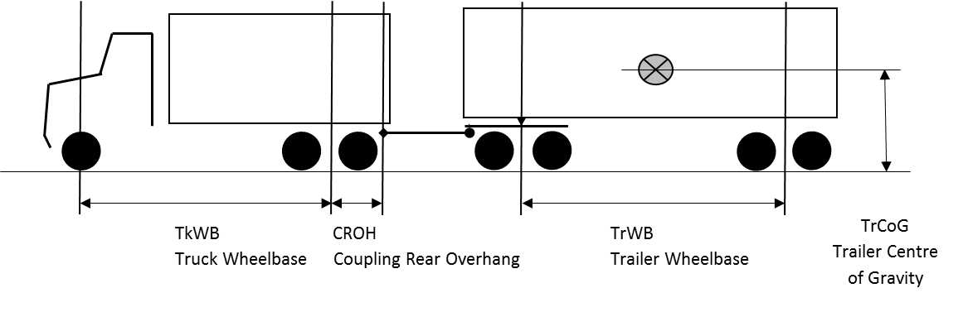

**APPENDIX 1**

**3 Axle Truck and 3 Axle Dog Trailer (R12T12) at 45 tonnes GCM**

4.8 * TrWB + 2.0 * TkWB – 4.95 * CROH - 19.0 * TrCoG > - 16.8

Or the simplified formula can be applied

4.8 * TrWB + 2.0 * TkWB – 4.95 * CROH > TDS

|  |  |  |
| --- | --- | --- |
| **Trailer CoG Height (m)** | **Typical Corresponding Body Type** | **TDS** |
| **1.7** | Tipper | **15.5** |
| **1.8** | Low-CoG Tanker | **17.4** |
| **2.2** | Conventional Tanker | **25.0** |
| **2.4** | General Freight | **28.8** |

where CROH = Coupling Rear OverHang (m)

TrCoG = Trailer Centre of Gravity height (m)

TrWB = Trailer WheelBase (m)

TkWB = Truck WheelBase (m)

TDS = Truck and Dog Stability parameter

**Example Calculation**

4.8 * TrWB + 2.0 * TkWB – 4.95 * CROH > 15.5

Sample combination tipper as a 3 axle truck with a 3 axle dog trailer (R12T12) at 45 T GCM

Trailer WheelBase = 3.8 m minimum allowable wheelbase for a 3 axle trailer

Trailer CoG Height = 1.7 m

Truck WheelBase = 4.5 m minimum allowable wheelbase for a truck

Coupling Rear OverHang = 1.8 m

4.8 * 3.8 + 2.0 * 4.5 – 4.95 * 1.8 > 15.5

. 18.24 + 9.0 – 8.91 > 15.5

. 18.33 > 15.5 the combination passes, exceeding the

minimum TDS parameter for tippers.

**APPENDIX 2**

**3 Axle Truck and 3 Axle Dog Trailer (R12T12) at 48 tonnes GCM**

**4 Axle Truck and 3 Axle Dog Trailer (R22T12) at 50 tonnes GCM**

4.8 * TrWB + 2.0 * TkWB – 4.95 * CROH - 19.0 * TrCoG > - 15.1

Or the simplified formula can be applied

4.8 * TrWB + 2.0 * TkWB – 4.95 * CROH > TDS

|  |  |  |
| --- | --- | --- |
| **Trailer CoG Height (m)** | **Typical Corresponding Body Type** | **TDS** |
| **1.7** | Tipper | **17.2** |
| **1.8** | Low-CoG Tanker | **19.1** |
| **2.2** | Conventional Tanker | **26.7** |
| **2.4** | General Freight | **30.5** |

where CROH = Coupling Rear OverHang (m)

TrCoG = Trailer Centre of Gravity height (m)

TrWB = Trailer WheelBase (m)

TkWB = Truck WheelBase (m)

TDS = Truck and Dog Stability parameter

**Example Calculation**

4.8 * TrWB + 2.0 * TkWB – 4.95 * CROH > 17.2

Sample combination tipper as a 4 axle truck with a 3 axle dog trailer (R22T12) at 50 T GCM

Trailer WheelBase = 3.8 m minimum allowable wheelbase for a 3 axle trailer

Trailer CoG Height = 1.7 m

Truck WheelBase = 5.0 m

Coupling Rear OverHang = 1.8 m

4.8 * 3.8 + 2.0 * 5.0 – 4.95 * 1.8 > 17.2

. 18.24 + 10.0 – 8.91 > 17.2

. 19.33 > 17.2 the combination passes, exceeding the   
 minimum TDS parameter for tippers

**APPENDIX 3**

**3 Axle Truck and 4 Axle Dog Trailer (R12T22) at 50 tonnes GCM**

**4 Axle Truck and 4 Axle Dog Trailer (R22T22) at 50 tonnes GCM**

TrWB + 1.24 * TkWB – 3.0 * CROH – 14.1 * TrCoG > - 25.0

Or the simplified formula can be applied

TrWB + 1.24 * TkWB – 3.0 * CROH > TDS

|  |  |  |
| --- | --- | --- |
| **Trailer CoG Height (m)** | **Typical Corresponding Body Type** | **TDS** |
| **1.7** | Tipper | **-1.1** |
| **1.8** | Low-CoG Tanker | **0.3** |
| **2.2** | Conventional Tanker | **6.0** |
| **2.4** | General Freight | **8.8** |

where CROH = Coupling Rear OverHang (m)

TrCoG = Trailer Centre of Gravity height (m)

TrWB = Trailer WheelBase (m)

TkWB = Truck WheelBase (m)

TDS = Truck and Dog Stability parameter

**Example Calculation**

TrWB + 1.24 * TkWB – 3.0 * CROH > -1.1

Sample combination tipper as a 3 axle truck with a 4 axle dog trailer (R12T22) at 50 T GCM

Trailer WheelBase = 4.6 m minimum allowable wheelbase for a 4 axle trailer

Trailer CoG Height = 1.7 m

Truck WheelBase = 4.5 m minimum allowable wheelbase for a 3 axle truck

Coupling Rear OverHang = 1.8 m

4.6 + 1.24 * 4.5 – 4.95 * 1.8 > -1.1

4.6 + 5.58 – 8.91 > -1.1

. 1.27 > -1.1 the combination passes, exceeding the  
 minimum TDS parameter for tippers.

**APPENDIX 4**

**Total Roll Stiffness Versus Roll Centre height**



**The combination needs to be above the line**

**Trailer Suspension   
Roll Centre Height (m)**

Assumptions:

* Trailer Tyres 11R22.5
* Tyre Vertical Stiffness = 790,000 N/m
* Trailer Axle Track Width = 1.8 m
* Tyre Corning Stiffness = 6,100 N/deg

If your trailer does not meet or exceed the assumptions listed above, refer to an engineering consultant to assess your truck and dog combination.

**Note:** Trailer suspension supplier should provide statement of compliance for suspension/wheel/tyre combination that roll centre height for the trailer is greater than the minimum specified by the above graph for axle group or trailer suspension total roll stiffness.

**APPENDIX 5**

Distribution of Truck and Dog Stability (TDS) parameter versus trailer centre of gravity   
height for three (3) of the common truck and trailer configurations.



R12T12 combination at 48 tonne GCM

R12T12 combination at 45 tonne GCM

R12T22 combination at 50 tonne GCM

**[](http://www.atatruck.net.au/public/members-sponsors/itc-members)**

**About the ATA Industry Technical Council:**

The Industry Technical Council (ITC) is a standing committee of the Australian Trucking Association ([ATA](http://www.truck.net.au)). The ITC’s mission is to improve trucking equipment, its maintenance and maintenance management. The ITC was established in 1995.

As a group, the ITC provides the ATA with robust professional advice on technical matters to help underpin the ATA’s evidence based policymaking. It is concerned with lifting technical and maintenance standards, improving the operational safety of the heavy vehicle sector, and the development of guidelines and standards for technical matters.

ITC performs a unique service in the Australian trucking industry by bringing operators, suppliers, engineers and other specialists together in a long-term discussion forum. Its members provide expert and independent advice in the field to inform the work of the ITC. The outcomes from ITC benefit all ITC stakeholders and the heavy vehicle industry at large.

The ITC operates under the Australian Trucking Association’s Council, which formulates industry policy for implementation by the organisation.

**Joining ITC:**

We welcome applications to join the ITC. For further information,

please call the ATA (02) 6253 6900 or

email ata@truck.net.au

or download information from the ATA website www.truck.net.au follow the links under the members tab to join here.

1. Hendry, B. and B. Coleman. (2002) “Review of Truck and Dog Trailer Operations Over 42.5 Tonnes Gross Vehicle Mass,” 7th International Symposium Heavy Vehicle Weights and Dimensions, June 16-20, Delft, The Netherlands.

   2 The PBS mandatory requirement for High Speed Transient Off-tracking (HSTO) is 0.6 for level one and two truck and dog trailers. The ATA believes the lower level of 0.8 is acceptable, however, your PBS application must comply with the standard.