Construction Logistics and Community Safety – Australia Standard (draft outline)

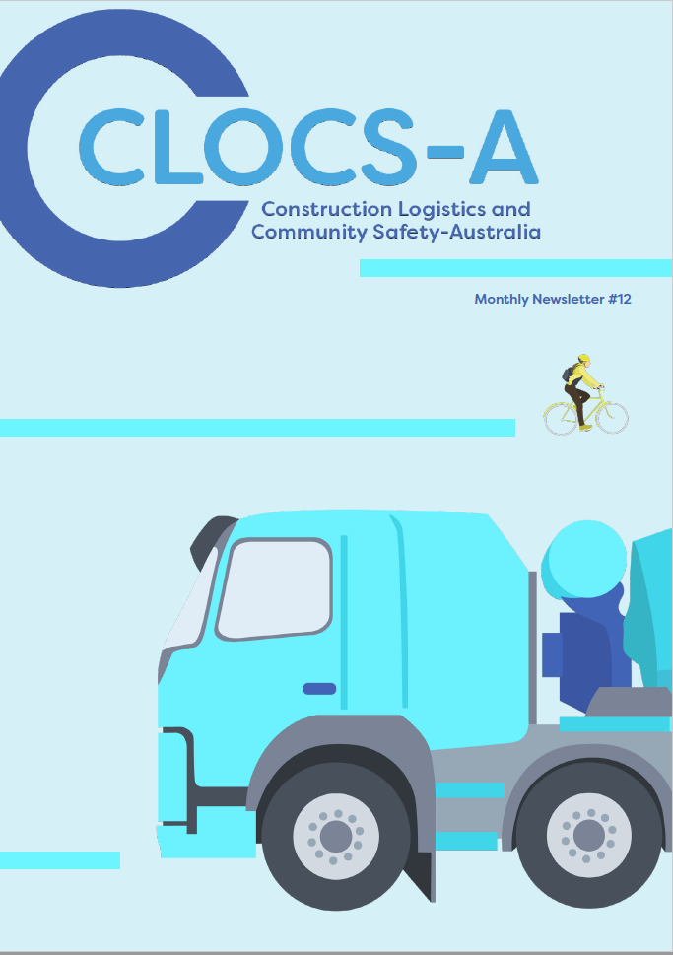
Table of Contents
1. Introduction 4
2. Steering Group and Supporting Partners 5
3. Overview 6
Mission 6
Goals 6
Scope and Application 6
Key Stakeholders 7
4. Definitions 8
5. Requirements 9
5.1 Stakeholder Group 1 - Planning Authorities and Regulators 10
5.1.1 Planning Conditions 10
5.1.2 Monitoring and Reporting 10
5.1.3 Corrective / Remedial Actions 10
5.2 Stakeholder Group 2 - Clients/ Developers 11
5.2.1 Risk Assessment 11
5.2.2 Route Assessments 11
5.2.3 Safety in Planning and Design 11
5.2.4 Procurement of Principal Contractors 11
5.2.5 Procurement of Transport Operators 12
5.2.6 Monitoring and Assurance 12
5.2.7 Incident and Performance Reporting 12
5.2.8 Communications and Engagement 12
5.3 Stakeholder Group 3 - Principal Contractors 13
5.3.1 Risk Assessment 13
5.3.2 Route Assessments and Planning 13
5.3.3 Construction Logistics Management Plan 13
5.3.4 Construction Traffic Management Plan 13
5.3.5 Planned Measures 14
5.3.6 Procurement of Transport Operators 14
5.3.7 Project Rules and Requirements 14
5.3.8 Monitoring of Construction Transport Activities 15
5.3.9 Incident Reporting 15
5.3.10 Performance Reporting 15
5.3.11 Communications and Engagement 15
5.4. Stakeholder Group 4 - Transport Operators 16
5.4.1 Vehicle Safety Requirements 16
5.4.2 Vehicle Maintenance 16
5.4.3 Driver Licence Verification 16
5.4.4 Driver Training and Competency 16
5.4.5 Driver Fitness for Duty 17
5.4.6 Safe Driving Behaviours and Road Safety Culture 17
5.4.7 Incident and Performance Reporting 18
5.4.8 Performance Reporting 18
5.4.8 Communications and Engagement 18
6 Case Studies 19
7 Contacts and Further Information 20
Appendix A – Construction Logistics Planned Measures 21
Appendix B – Communications Standard 23
Appendix C – Construction Logistics Management Plan Criteria 25
Appendix D – CLOCS-A Reporting Metrics 26
Appendix E - CLOCS-A Vehicle Safety Specification 27
Appendix E1- CLOCS-A Vehicle Safety Specification 27
Appendix F – Driver Training and Competency Standard 29
F1 - Vulnerable Road User Awareness Training Requirements per Accreditation Level 29
F2 – Low Risk Driving Skills Training Requirements per Accreditation Level 30

Introduction
Australian governments are committed to an expected $290 billion in public infrastructure investment over the next 10 years - including an approximate doubling of investment over the next three years. This will mean a wave of construction projects mostly relating to transport, utilities and social infrastructure. Many of these projects will be in cities, towns and urban areas.
As a direct result of this increase in construction activity, the number of heavy vehicle movements in those project locations will also increase significantly.
Recognising that the movement of these construction vehicles in populated areas can present hazards for the public – particularly Vulnerable Road Users – both State and Commonwealth governments seek to prioritise and promote the use of safer heavy vehicles, improved driver standards, more effective logistics planning and greater engagement with the community on road safety initiatives.
Construction Logistics and Community Safety – Australia (“CLOCS-A”) is a national voluntary Standard developed with the primary aim of better managing the potential hazards created by the road transport and logistics activities associated with large construction projects.
It is the result of the collective effort of industry champions involved in construction projects and the supply chain.
Through the wider adoption of the CLOCS-A Standard across Australian construction supply chains, it is expected that the risk of road trauma involving construction vehicles will be reduced and the efficiency of construction project logistics improved.

Steering Group and Supporting Partners

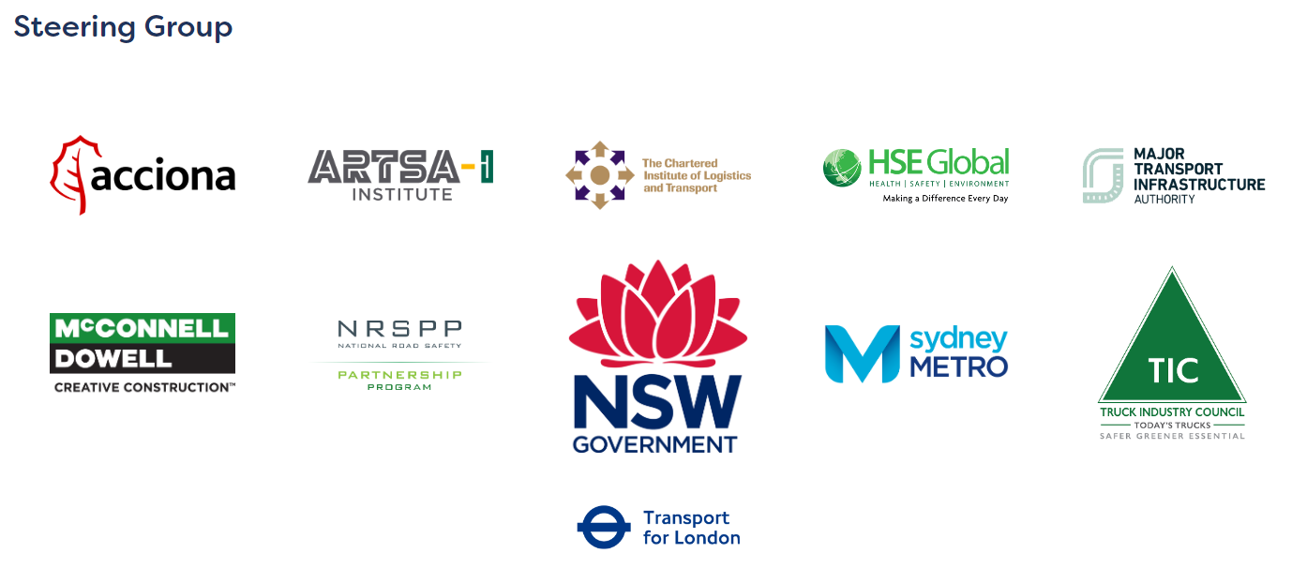

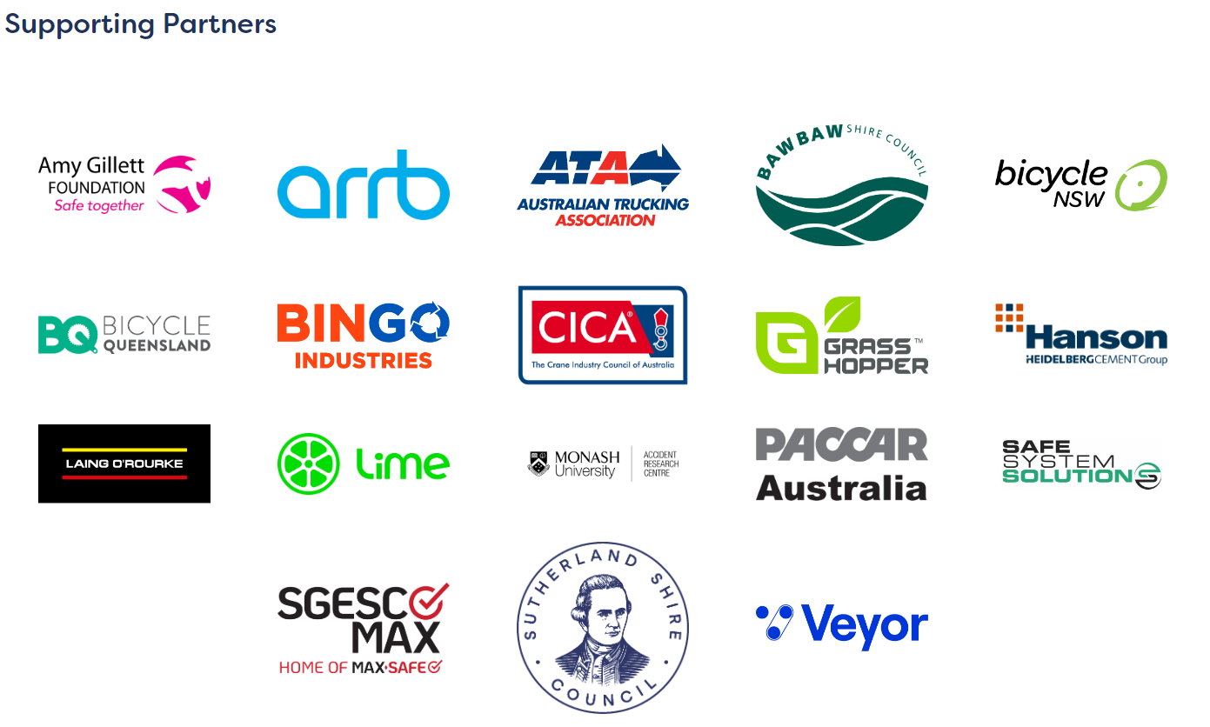

Overview
The primary aims of the CLOCS-A Standard is to help protect the public from harm and to improve the quality of construction logistics planning. It seeks to do so by:
- establishing a set of minimum standards for heavy vehicles
- establishing minimum heavy vehicle driver education and training standards
- establishing higher standards for haulage route assessment and logistics, and
- improving communication and levels of understanding around heavy vehicle safety with the public
CLOCS-A provides a quality assurance mechanism that tests whether relevant systems are in place to ensure that expected standards of safety management are met.

Mission
The mission of CLOCS-A is simple – to ensure the safest, leanest, and greenest construction vehicle journeys

Goals
The primary goals of CLOCS-A are:
- Zero incidents and collisions between construction vehicles and the community
- Increased productivity and efficiency
- Fewer heavy vehicle journeys
- Better planning of construction logistics
- Improved air quality and reduced emissions
- Reduced reputational risk

Scope and Application
The CLOCS-A Standard shall be applied by stakeholders involved in the procurement and delivery of construction projects that are publicly funded.
Clients shall specify whether the CLOCS-A Standard applies within contracts based on their assessment of risk and in accordance with any local authority requirements.
Queries regarding applicability at specific sites should be directed to, and dealt with, by the client or principal contractor.
Unless otherwise stated it is:
- applicable to all sites, (projects) that require deliveries, collections or servicing by construction vehicles during construction activities
- applicable to all vehicle operations and specifically construction logistics vehicles over 4.5 tonnes gross vehicle mass servicing construction sites. This includes abnormal loads and engineering plant where practicable.
A client may specify within their own contracts if this Standard also applies to vehicles under 4.5 tonnes gross vehicle mass, but this should be clearly articulated and would not be considered in the scope of compliance with the CLOCS-A Standard. In such cases, the transport operator will agree with the client how compliance for this group of vehicles will be demonstrated.
All parties shall comply with the CLOCS-A Standard and maintain compliance to the Standard following gaining accreditation to the CLOCS-A Standard.
The CLOCS-A Standard does not include all the necessary provisions of a contract. Users are responsible for its correct application.

Key Stakeholders
Key stakeholders with roles and responsibilities for implementing the requirements of the CLOCS-A Standard include:
- Planning and Regulatory Authorities
- Government Clients/ Developers
- Construction Principal Contractors
- Companies providing Road Transport

Definitions
ADR | Australian Design Rule
Client (including Developers) | Clients are stakeholders in a construction project responsible for the commissioning and funding to construction Principal Contractors to design and construct infrastructure or other building developments.
CLOCS-A | Construction Logistics and Community Safety - Australia
Construction Project | Any work carried out in connection with the construction, alteration, conversion, fitting-out, commissioning, renovation, repair, maintenance, refurbishment, demolition, decommissioning or dismantling of a structure where the cost of the work is $250 000 or more.
Delivery Management System (DMS) | A tool used to streamline the delivery process from start to finish. DMSs are used to improve operations by supporting the planning and management of bookings and optimising routes to increase the efficiency of deliveries.
Heavy Vehicle | A vehicle that has a gross vehicle mass (GVM) or aggregate trailer mass (ATM) of more than 4.5 tonnes. The GVM of a vehicle is the maximum it can weigh when fully loaded, as specified by the manufacturer.
HVNL | Heavy Vehicle National Law
NHVR | National Heavy Vehicle Regulator
OHS | Occupational Health and Safety
Principal Contractor | The entity responsible for the construction of the project, who has management and control of the workplace(s) where the construction work will take place. Principal Contractor’s responsibilities include the planning and procurement of supplies and services that require construction vehicle deliveries to and from the Principal Contractor’s construction site(s).
Transport Operator | The entity responsible for controlling or directing the use of a vehicle (or fleet of vehicles) or the towing vehicle in a combination.
Vulnerable Road User | Road users not in a car, bus or truck, generally considered to include pedestrians, motorcycle riders, cyclists, children 7-years and under, the elderly and users of mobility devices. In the event of a crash, VRUs have little to no protection from crash forces.
WHS | Work Health and Safety

Requirements
The following section sets out the requirements for each of the four stakeholder groups to a construction project in relation to meeting the CLOCS-A Standard.
Compliance against each requirement is needed to be a CLOCS-A accredited party.
CLOCS-A Accreditation is awarded on a 3-tiered approach. These are Bronze – Silver – Gold status.
Status level for a CLOCS-A party is based on meeting certain defined criteria set out in this standard. Accreditation and level shall be awarded following a system of Self-Assessment, entry audits, reviews and follow-up audits.

Stakeholder Group 1 - Planning Authorities and Regulators
Planning Authorities and Regulators consist of government authorities responsible for approving construction projects to go ahead and issuing conditions as part of the construction project to comply with. These typically include Planning Departments and Local Councils.

Planning Conditions
Planning Authorities shall:
- Ensure, where a construction project is assessed to introduce traffic and transport impacts to the community, conditions of approval issued to the project specify that the construction project take all necessary measures to mitigate the risks and impacts to community road users from construction transport and logistics activities through complying with the CLOCS-A Standard.

Monitoring and Reporting
Planning Authorities shall:
- Obtain evidence throughout the duration of the construction project to verify that construction project managers are implementing and maintaining measures as per the CLOCS-A Standard.

Corrective / Remedial Actions
Planning authorities shall:
- Have processes in place to manage instances of a breach and shall clearly communicate corrective / remedial actions required of the project team.

5.2 Stakeholder Group 2 - Clients/ Developers
Clients and Developers are responsible for commissioning and funding contracts to construction Principal Contractors to design and construct infrastructure or other building developments.

5.2.1 Risk Assessment
Clients/ Developers shall:
- Undertake a risk assessment during the planning and design phase of the construction project to identify and assess the project’s risks to public road user groups as a result of the project’s construction transport activities on the surrounding environment.
  - Risk Assessments of construction transport activities should consider factors including the local environment, volume, frequency and type of truck movements involved, historical crash data and incident trends.
  - Risk Registers should include the outputs of risk assessments, recording proposed mitigation measures to reduce the impacts and risks to the public.
  - Risk assessments shall be used to determine the minimum CLOCS-A Accreditation level (Bronze/ Silver/ Gold) to be specified in contracts.

5.2.2 Route Assessments
Clients/ Developers shall:
- Conduct risk assessments of proposed haulage routes servicing project construction sites, considering their interface with public road users, sensitive land use areas and potential for conflict with vulnerable road users.
  - Haulage route risk assessments may be conducted using industry-recognised tools such as the Human Impact Route Assessment (HIRA) tool.
  - Assessments shall be communicated to the Principal Contractor upon contract award.

5.2.3 Safety in Planning and Design
Clients/ Developers shall:
- Investigate, consider and specify, where reasonably practicable, measures to reduce heavy vehicle movements / deliveries to the project’s construction sites. Options may include:
  - Procurement of land (e.g., for the purposes of laydown, materials consolidation, truck marshalling, etc.)
  - Use of Alternative transport modes
  - Re-use of materials / spoil onsite
  - Prefabrication at an off-site location
  - Truck marshalling facilities/ areas
(See Appendix A – Construction Logistics Planned Measures)

5.2.4 Procurement of Principal Contractors
Clients/ Developers shall:
- Ensure contracts awarded to construction Principal Contractors specify that compliance to the CLOCS-A Standard shall be met by the Principal Contractor and their transport supply chain.

5.2.5 Procurement of Transport Operators
Clients/ Developers shall:
- Ensure, where engaging in contracts directly with a Transport Operator, contracts awarded to the Transport Operator specify compliance to the CLOCS-A Standard that must be met by the Transport Operator and their supply chain.

5.2.6 Monitoring and Assurance
Clients/ Developers shall:
- Verify CLOCS-A accreditation of the Principal Contractor and major transport subcontractors throughout the tender procurement phase and following through to the contract being awarded.
- Ensure Principal Contractors report on CLOCS-A Accreditation status periodically throughout project, notifying any changes to the accreditation requirements, and if applicable, the action plan to regain accreditation.

5.2.7 Incident and Performance Reporting
Clients/ Developers shall:
- Ensure Principal Contractors report on transport-related incidents (crashes, loss of load, impacts with infrastructure, near misses, unsafe behaviour) and appropriate corrective and preventative actions taken to prevent such recurrences in accordance with Appendix D – CLOCS-A Reporting Metrics

5.2.8 Communications and Engagement
Clients/ Developers shall:
- Ensure implementation of Community Engagement Communications & Activities is carried out in accordance with the Appendix B - Communications Standard

5.3 Stakeholder Group 3 - Principal Contractors
Principal Contractors are responsible for the construction of the project, including the planning and procurement of supplies and services that require construction vehicle deliveries to and from the project construction sites.

5.3.1 Risk Assessment
Principal Contractors shall:
- Undertake risk assessments during the initial stages of the construction project to identify and assess the project’s risks to public road users as a result of generating construction freight to/ from its construction sites.
  - Risk Assessments of construction transport activities should consider factors including the local environment, volume, frequency and type of truck movements involved, and even historical crash data and incident trends.
  - Risk Registers should include the outputs of risk assessments, recording the agreed mitigation measures to reduce impacts and risks to the public.

5.3.2 Route Assessments and Planning
Principal Contractors shall:
- Ensure specific haulage route risk assessments are undertaken in consultation with relevant stakeholders to assess and select the safest haulage routes to and from the construction site to the closest arterial or collector road.
  - Haulage route risk assessments may be conducted using industry-recognised tools such as the Human Impact Route Assessment (HIRA) tool.
- Document and implement a procedure for route planning which outlines the preferred haulage routes identified servicing the construction project sites, route hazards by type, route instructions and communication, routes agreed upon for the specific vehicle types and any applicable access approvals.

5.3.3 Construction Logistics Management Plan
Principal Contractors shall:
- Develop, implement, and maintain a project-specific construction logistics management plan (“CLMP”) which provides the framework for planning and managing construction activity into and out of a proposed construction project site(s). The CLMP shall address the criteria outlined in Appendix C – Construction Logistics Management Plan.
Responsible person: Logistics Manager or Construction Manager

5.3.4 Construction Traffic Management Plan
Principal Contractors shall:
- Develop, implement, and review a project-specific construction traffic management plan (“CTMP”) (or equivalent) which describes how traffic will be managed when construction works are being carried out, the work activities being proposed, their impact on the roadway and on road users, including vulnerable road users, and how these impacts are being addressed.
  - CTMP’s must incorporate Traffic Staging Plans, Traffic Control Plans and Vehicle Movement Plans. Pedestrian Movement Plans should also be incorporated where relevant.
  - CTMPs should be developed in accordance with the local road authorities’ requirements for traffic management around construction sites and worksites (e.g., Austroads, TfNSW, VicRoads, MUTCD, etc.)
Responsible person: Traffic Manager or Construction Manager

5.3.5 Planned Measures
Principal Contractors shall:
- Investigate, consider and implement, where reasonably practicable, measures to minimise the impact of the construction project’s cumulative transport and logistics movements on the local road network, (e.g., such as through the adoption of new technology or planning tools enabling further productivity and efficiencies)
  - Planned measures committed to by the constructor shall be captured in the project’s Construction Logistics Management Plan
  - Planned measures may include a range of, but not limited to, those listed in Appendix A – Construction Logistics Planned Measures.
Gold Accreditation Requirement
5.3.5 c) Demonstrate measurable improvements to the project’s safety, productivity and efficiency following implementation of Planned Measures.

Silver Accreditation Requirement
5.3.5 b) Demonstrate evidence of continuous improvement by moving from investigating to implementation of Planned Measures.
Responsible person: Sustainability Manager, Logistics Manager or Construction Manager

5.3.6 Procurement of Transport Operators
Principal Contractors shall:
- Ensure contracts issued to Transport Operators specify compliance with the CLOCS-A Standard.
- Ensure Transport Operators engaged through contracts provide evidence of compliance to the CLOCS-A Standard.
- Where CLOCS-A accredited Transport Operators cannot be engaged, Principal Contractors shall ensure a plan is implemented by the Transport Operator engaged to achieve CLOCS-A accreditation by an agreed timeframe and in the interim have in place processes to verify and validate the Transport Operators existing Road Transport Safety Management Systems.
Responsible person: Procurement Manager and Health and Safety Manager or Logistics Manager

5.3.7 Project Rules and Requirements
Principal Contractors shall:
- Implement a process to ensure heavy vehicle drivers engaged to undertake transport activities on behalf of the Principal Contractor hold a valid and appropriate licence for the class of vehicle operated on the Principal Contractor’s construction project.
- Ensure heavy vehicle drivers working on the Principal Contractor’s project have completed the required level of training as required by the CLOCS-A Standard.
- Ensure a project-specific induction is provided to heavy vehicle drivers engaged by the Principal Contactor communicating as a minimum applicable approved construction haulage routes, any and all restrictions that may apply and any identified traffic safety risks in the surrounding local environment.
- Document and implement a drug and alcohol policy and associated drug and alcohol testing program on its project construction sites which can be applied to heavy vehicle drivers engaged by the Principal Contractor.
- Develop and implement a process which clearly communicates the expectations of heavy vehicle drivers working on the Principal Contractor’s construction project and operating in the local community.
Responsible person: Health and Safety Manager or Logistics Manager

5.3.8 Monitoring of Construction Transport Activities
Principal Contractors shall:
- Implement a system to monitor the safety and compliance of construction deliveries to and from the Principal Contractor’s project sites.
  - Monitoring of activities shall take into account compliance with approved haulage routes, CLOCS-A compliance status of vehicles delivering to sites, any deviation or non-compliances identified, and any corrective actions taken.
Responsible person: Logistics Manager or Construction Manager

5.3.9 Incident Reporting
Principal Contractors shall:
- Ensure any transport-related incidents and community complaints associated with the construction projects activities, and its supply chain, are reported and investigated to a level commensurate to the severity of the incident and/or complaint.
- Ensure appropriate corrective actions and lessons learnt are disseminated to the CLOCS-A Community following any transport-related incidents or complaints where there was an actual or potential fatality or serious injury to a driver, worker or member of public.

5.3.10 Performance Reporting
Principal Contractors Shall:
- Periodically report (Monthly, Quarterly/ Annually/ Project to date) to the Client on the CLOCS-A metrics throughout the duration of the construction project. Refer to Appendix D for CLOCS-A Reporting Metrics.
- Report on CLOCS-A Accreditation status periodically throughout project, notifying of when CLOCS-A audits have occurred, recommendations/ findings and any changes to accreditation and if applicable, details on the action plan to regain accreditation.

5.3.11 Communications and Engagement
Principal Contractors shall:
- Ensure implementation of Community Engagement Communications & Activities is carried out in accordance with the Appendix B - Communications Standard

5.4. Stakeholder Group 4 - Transport Operators
Transport Operators are: any business or undertaking employed directly by the Principal Contractor that is responsible for controlling or directing the use of heavy vehicles to deliver to/from a construction site/development.
Transport Operators that subcontract any transport activities to any other parties are responsible for ensuring full compliance by those other parties to all aspects and requirements of this Clause 5.4

5.4.1 Vehicle Safety Requirements
Transport Operators shall:
- Ensure heavy vehicles accredited to the CLOCS-A Standard and/or operating on CLOCS-A accredited construction projects comply with the vehicle safety specifications in Appendix E - CLOCS-A Vehicle Safety Specification

5.4.2 Vehicle Maintenance
Transport Operators shall:
- Document and implement a maintenance management system to manage the routine planned and unplanned maintenance of the transport operator’s heavy vehicle fleet, including a Driver’s Daily Pre-start Check and the reporting and rectification of faults or defects identified.

5.4.3 Driver Licence Verification
Transport Operators shall:
- Ensure heavy vehicle drivers engaged (including subcontractors) hold an appropriate and valid class of licence for the vehicle in which they are engaged to drive.

- Implement a process to periodically check and verify heavy vehicle driver licences, including their category, expiry date, and any restrictions are complied with.

5.4.4 Driver Training and Competency
Transport Operators shall:
- Ensure heavy vehicle drivers engaged (including subcontractors) have completed training and obtained competencies in the following skills:
    - Vulnerable Road User awareness
    - Low-risk heavy vehicle driving skills
    - Safe loading and unloading
    - Load restraint
    - Pre-start vehicle inspection
    - Fatigue management
    - Breakdown safety
Refer to Appendix F – Driver Training and Competency Standard
- Implement and maintain a Training Needs Analysis to identify and document the necessary training, competencies, and ongoing skills and knowledge development needs (including refresher training) for heavy vehicle drivers engaged by the transport operator.

5.4.5 Driver Fitness for Duty
Transport Operators shall:
- Document and implement a pre-employment medical process which ensures drivers are medically assessed as per the Austroads’ Assessing Fitness to Drive (AFTD) national driver medical standards.

- Document and implement a process to check on the currency of the required periodic medicals assessments of the heavy vehicle drivers, including any requirements for ongoing Health Surveillance.

- Document and implement a Drug and Alcohol Policy and associated Drug and Alcohol Testing Program.
  - The Drug and Alcohol Testing Program must include a process for risk-based, random, and post-incident testing.
  - Document and implement a Fatigue Management Policy and Fatigue Management Procedures.
  - Fatigue management procedures must include a process for heavy vehicle drivers to declare their fitness to drive prior to commencing and during work to notify the operator if they are unfit for duty due to any lifestyle, health, or medical issues.
Gold Accreditation Requirement
5.4.5 e) Undertake a workplace design and task analysis to identify any restrictions or limitations to the driver’s workplace (i.e. vehicle cab design, ergonomics, access/ egress, etc.) and improvements that can be made to optimise the safety of the driver’s workplace.

Silver Accreditation Requirement
5.4.5 d) Implement documented procedures for ensuring heavy vehicle driver health and wellbeing, including health promotion strategies.

5.4.6 Safe Driving Behaviours and Road Safety Culture
Transport Operators must:
- Develop and implement a Driver Code of Conduct (or Safe Driving Policy) which clearly communicates the safe driving expectations when working for the Transport Operator at all times.
- Develop and implement a mobile phone/ in-cab distraction policy which provides drivers with clear expectations as to the company’s policy on the use of mobile phones and minimising in-cab distractions.
- Develop and deliver a series of heavy vehicle driver toolbox talks which provide drivers with up-to-date and on-going knowledge and awareness of safety alerts, hazards, issues affecting the industry and work activities in relation to the operation of heavy vehicles in the construction sector.
- Monitor safe driving behaviours on public roads periodically as determined by a risk assessment.
  - Aspects of driving behaviour which must be monitored include driver speed, harsh acceleration and/ or braking, following distances/ crash avoidance space.

- Implement a process to identify non-compliances and unsafe driving behaviours and establish corrective actions and disciplinary measures where appropriate.
Gold Accreditation Requirement
5.4.6 g) Have procedures in place to monitor, review and coach on safe heavy vehicle driving behaviours using a combination telematics monitoring data, forward facing and in-cab camera footage.

Silver Accreditation Requirement
5.4.6 f) Implement a ‘Reward and Recognition’ program to identify, reward and recognise exemplary low risk driving standards and behaviours within the organisation and encourage its continual application.

5.4.7 Incident and Performance Reporting
Transport Operators shall:
- Ensure any transport-related incidents and complaints associated with the transport operator’s activities and supply chain engaged are reported and investigated to a level commensurate to the severity of the incident and/or complaint.

- Ensure appropriate corrective actions and that the lessons learnt are disseminated to the CLOCS-A Community following any transport-related incidents or complaints where there was an actual or potential fatality or serious injury to a driver, worker or member of public.

5.4.8 Performance Reporting
Transport Operators shall:
- Periodically report (Monthly, Quarterly/ Annually/ Project to date) to the Principal Contractor on the following metrics throughout the duration of the construction project. Refer to Appendix D for CLOCS-A Reporting Metrics.
- Report on CLOCS-A Accreditation status periodically throughout project, notifying of when CLOCS-A audits have occurred, recommendations/ findings and any changes to accreditation and if applicable, details on the action plan to regain accreditation.

5.4.8 Communications and Engagement
Transport Operators shall:
- Ensure implementation of Community Engagement Communications & Activities and Vehicle Branding is carried out in accordance with the Appendix B - Communications Standard

6 Case Studies
The following section provides a number of case studies from industry champions who have implemented various initiatives and programs within their organisation under the CLOCS-A Standard.
Each case study has been developed with the intent to describe how the organisation went about implementing the specific initiative or program, how they overcame any challenges and the benefits the organisation has experienced since implementation.
[under development]

7 Contacts and Further Information
- CLOCS-A Website: https://www.clocs-a.org.au/
- National Heavy vehicle Regulator: https://www.nhvr.gov.au/
- Safe Work Australia: https://www.safeworkaustralia.gov.au/
- National Road Safety Partnership Program: https://www.nrspp.org.au/
- CILTA: https://www.cilta.com.au/

Appendix A – Construction Logistics Planned Measures
Planning a construction project’s logistics can significantly reduce the impacts and risks to the community through measures which optimise the efficiency of logistics activities. Optimisation of construction logistics can lead to significantly reducing the number and frequency of heavy vehicle movements on a construction project through measures such as:
A.1 MODE SHIFT
Using transport modes, such as by rail or marine methods as an alternative to roads, can be a cost-effective and efficient way of transporting a range of construction materials, plant and equipment and should be considered by infrastructure and construction projects located in proximity to nearby rail freight lines and/or waterways.
Such alternative modes provide additional sustainable benefits by reducing vehicle emissions and improving safety by significantly reducing construction vehicle movements.
Example: Sydney Metro’s City and Southwest Project established and operated a temporary barging facility at Barangaroo to deliver Tunnel Boring Machine equipment and remove excavated spoil by barge, reducing traffic impacts to the community and cutting thousands of truck movements on busy inner-Sydney roads.
A.2 RE-USE OF MATERIALS
Re-use of materials, such as excavated spoil and earthworks within a construction site boundary is also an effective way of eliminating or reducing construction transport off-site and can provide sustainable benefits by contributing to a project’s waste management objectives.
A.3 PREFABRICATION
Prefabrication of structures off-site can reduce the number of construction vehicle movements required to deliver construction materials, plant, and equipment to sites.
In addition, prefabricated structures which are over-size/over-mass can be transported to site in a more highly controlled manner which can be done at night, under escort, and with careful route assessment and planning.
Not only does prefabrication reduce risks on the road, but it can also minimise on-site WHS risks, by reducing site congestion and the need to carry-out various high-risk construction activities in order to build the structure on site.
A.4 HIGHER-PRODUCTIVITY VEHICLES
Optimising the efficiency of construction heavy vehicles used on infrastructure and construction projects can provide both productivity and safety benefits to the project through the use of higher-productivity or performance-based standards (PBS) heavy vehicles.
Such vehicles can carry higher payloads than general access heavy vehicles operating under regulatory general mass limits, thereby reducing the overall number of heavy vehicle movements required.
A.5 CONSOLIDATING LOADS/DELIVERIES
Heavy vehicle transport for construction can also be optimised by consolidating deliveries or loads onto one vehicle destined for a project with multiple sites or multiple construction projects located nearby using a common supplier.
A.6 DELIVERY SCHEDULING
Scheduling and retiming deliveries to avoid peak periods can naturally reduce congestion and exposure risk. Planning deliveries during less congested hours allows site-related vehicles to operate more efficiently and reduce the risk of collisions.
Construction deliveries and collections made outside of peak traffic times are also more likely to arrive on time, which can reduce potential on-site delays. They also reduce congestion in the vicinity of the site.
Utilising a Delivery Management System (DMS) – whether electronic or paper-based – can significantly improve the reliability of delivery for critical items and coordination of a site’s booking and delivery process, ensuring the flow of vehicles to and from sites are controlled.
Delivery management systems are also recommended to ensure that everyone in the transport supply chain is able to:
• confirm the routes taken by vehicles in their journey to and from site
• ensure that site supervisors are trained in what technologies vehicles arriving on site should be fitted with
• have a process for checking the driver has appropriate training
• achieve efficiency improvements to project logistics.
A.7 TRUCK MARSHALLING
Where construction sites are limited for space, providing off-site truck marshalling facilities or approved marshalling areas en-route to site in collaboration with local authorities can reduce heavy vehicle movements from circling construction sites that are waiting to be ‘called-in’ or construction vehicles parking in unapproved locations which might pose a hazard to other road users (i.e. by obscuring sight distance or blocking visibility to local driveways or pedestrian crossings).
Providing such facilities can reduce emissions, fuel consumption and road safety risks, however requires collaboration from local authorities.
A.8 HAUL ROADS AND SITE STANDARDS
Sites should be designed in such a way that provide sufficient space for laydown of materials and to prevent heavy vehicles queuing on local roads outside the construction site or in nearby streets.
Ground conditions for site haulage routes and load/unload areas should take into account the clearance requirements for on-road heavy vehicles, including rear overhang, and ground clearance for safer vehicle designs such as heavy vehicles with low-entry direct vision cabs and side/rear underrun protection

Appendix B – Communications Standard
Note: Communications Standards are applicable to all CLOCS-A accredited projects regardless of otherwise specified tier requirements.
No. | Communication Focus | Item | CLOCS-A Tiers |  | Responsible Stakeholder
 |  |  | Small Projects (Basic - Bronze)  (Risk based TBD) | Medium-Large Projects Silver/gold (Advanced)  (Risk Based TBD) | Government +  Regulators | Clients + Developers | Principal  Contractors | Vehicle + Transport  Operators | Community | Local Govt | Industry Groups
1 | Contract Clauses | Add communications engagement clause into contract requirements | All CLOCS-A Sites | All CLOCS-A Sites
2 | CLOCS-A Member | As a CLOCS-A Member will act as a champion for the program to those it operates/interacts with | CLOCS-A Memerbship logo and act as a champion. | CLOCS-A Membership logo and act as a champion.
3 | Community Engagement  Communications & Activities | CLOCS-A Tier Membership Insignia | All Site Entrances | All Site Entrances
4 |  | Contractor Safety Branding | All Site Entrances | All Site Entrances and surround fences (Depending upon govt requirements and conditions)
5 |  | Allocate and maintain primary contact's details | Yes | Yes
6 |  | CLOCS-A Community engagement process | Start and life of project | Start and life of project
7 |  | Community engagement along logistics routes and local communities (Communication activation campaign in a local area) | As per CLOCS-A guidelines | As per CLOCS-A guidelines
8 |  | CLOCS-A safety messaging at locations of higher risk or conflict points | As per CLOCS-A guidelines | As per CLOCS-A guidelines
9 |  | CLOCS-A community road safety activations,  engagement and awareness activities (swapping  seats, Truck Aware, Ride Along etc.) | Safety Communication Campaign:  Digital, print and social media engagement | Safety Communication Campaign:  Digital, print, social media  and in-person activations
10 |  | CLOCS-A Case Study and Learnings (As per Template) | One per project | Three per project
11 |  | Some form of monitoring of community complaints over time | Monthly | Monthly
12 | Vehicle  Branding & Communications | CLOCS-A Tier Membership Insignia | All Vehicles CLOCS-A Sticker next to NHVAS location or in its place | All Vehicles CLOCS-A Sticker next to NHVAS location or in its place
13 |  | CLOCS-A Be Truck Aware example or similar campaign (Voluntary) | optional | optional
14 |  | CLOCS-A Cyclists aware branding | All Vehicles | All Vehicles
15 |  | CLOCS-A Case Study (As per Template) | One per project | Three per project
16 |  | Vehicle Activation Partner (e.g. Ride Along) | N/A | Provide trucks and drivers for in-person activations as needed
17 |  | Truck maintained clean and presentable | All trucks | All trucks

Appendix C – Construction Logistics Management Plan Criteria
The CLMP shall address the following criteria:
- Assign the nominated stakeholders, including the appointed delegate(s) who will be responsible for the coordination and leadership of the CLOCS-A implementation, oversight, reporting and updating. This must be documented and communicated to the stakeholders on the project by the Principal Contractor.
- Detail the project’s construction logistics objectives and how they will be achieved
- Provide appropriate procurement clauses to be issued in tender documents and describe how they align with the Goals of CLOCS-A
- Detail the project’s risk assessment of construction transport activities and specify the safest vehicle routes and identified acceptable reasons for any time-to-time deviations
- Provide the forecasted construction logistics activities and material deliveries over each phase of the construction project
- Document required approvals and permits by level of government and application dates and duration, including:
  - Site Access for vehicle types
  - By route for each truck type
  - Over dimensional movements
  - Time of day movements approvals
  - Parking permission approvals (If applicable)
  - Impact on public transport vehicles
- Detail the Planned Measures considered and implemented to reduce impacts and risks on the project
- Identify appropriate community considerations
- Have regular input from significant project and transport operators
- Be updated within 3 months of changes to processes, plans or operating procedures.

Appendix D – CLOCS-A Reporting Metrics
D1 – Principal Contractor Reporting
CLOCS-A Reporting Metrics shall be reported monthly, quarterly and annually to the Client of the Construction project, including the following:
- Collisions involving construction vehicles servicing the project — Major, serious, moderate by own fleet and/or by contractor fleet, detailing:
  - Fatal incidents involving construction vehicles
  - Serious injury incidents involving construction vehicles
  - Truck type/configuration involved
- Number of heavy vehicle movements/ deliveries to project
- Number of heavy vehicles on project
- Number of construction traffic/ transport related complaints
- % of transport subcontractors accredited to CLOCS-A
- Number of compliant construction vehicles to CLOCS-A Standard
- Number of compliant drivers to CLOCS-A Standard
- Number of Community Engagement Activities
D2 – Transport Operator Reporting
CLOCS-A Reporting Metrics shall be reported monthly, quarterly and annually to the Client of the Construction project, including the following:
- Collisions involving the transport operators’ vehicles servicing the project — Major, serious, moderate by own fleet and/or by sub-contractor fleet, detailing:
  - Fatal incidents involving construction vehicles
  - Serious injury incidents involving construction vehicles
  - Truck type/configuration involved
- Number of heavy vehicle movements/ deliveries to Principal Contractor’s construction sites
- Number of heavy vehicles allocated to the project
- Status of CLOCS-A Accreditation
- Number of Community Engagement Activities

Appendix E - CLOCS-A Vehicle Safety Specification

Appendix E1- CLOCS-A Vehicle Safety Specification
Accreditation Level | Description | Vehicle Safety Requirement
Bronze | The Minimum Mandatory Standard for all heavy vehicles complying with CLOCS-A technical requirements.  Measures and technologies that are relatively low cost and easy to implement.  Accreditation requires compliance with at least one of the standards nominated as "either/OR" plus all remaining standards. | - No solid, clear or coloured bug deflectors mounted on bonneted trucks  - No external engine air intakes above bonnet level (on bonneted trucks)  - No large after-market bullbars that rise above the standard overall bumper height for the particular vehicle.  - No external sunvisors that protrude below the tinted band on the windscreen or the swept path of the wipers  - No large lettering or decals attached to any part of the windscreen  - No tinting of the windscreen or side windows that reduces light transmittance beyond legal levels  - No aftermarket accessories (such as screens or mobile phones) mounted inside the cab that create blind spots and/or obscure the driver's field of view  - Class V (Passenger side) and VI (front) blind spot mirrors  - Fresnel lens fitted to the passenger side window or peeper window  - Either Reversing cameras OR Reversing sensors  - Reverse beepers  - Amber beacons fitted to the roof of the cabin  - Conspicuity markings with retro-reflective tape  - High visibility drawbar colour scheme  - Vulnerable Road User warning signage  - Wheel-nut position indicators
Silver | A higher standard of equipment that is preferred for heavy vehicles complying with CLOCS-A technical requirements. Similar to UK CLOCS and broadly aligned to current NSW/VIC Government Major projects.  Accreditation requires compliance with at least one of the standards nominated as "either/OR" plus all remaining standards where applicable. | Achievement of Bronze Accreditation, plus the following:  - Either Left-side blind spot cameras OR Left-side proximity sensors  - Left turn audible warning  - Day run lights  - Front Underrun Protection  - Side Underrun Protection - Trucks  - Side Underrun Protection - Trailers  - Rear Underrun Protection  - Euro V Emission Standard  - ABS - for trucks  - ABS - for trailers
Gold | The highest standard of equipment that is being sought for heavy vehicles complying with CLOCS-A technical requirements. Encourages leading safety technologies & to future-proof vehicles.  Accreditation requires the fitment of telematics plus compliance to a minimum of 4 of the remaining standards where applicable. | Achievement of Silver Accreditation, plus the following:  - Telematics Monitoring System  - Roll Stability Control (Trailers)  - Electronic Stability Control (Trucks)  - Advanced Emergency Braking  - Lane Departure Warning  - Autonomous Reverse Braking  - Euro VI Emission Standard or Zero Emission Vehicle

Note: For further explanation and detail on all of the above Heavy Vehicle Safety Specifications, refer to the CLOCS-A Vehicle Safety Guide (under development).

Appendix F – Driver Training and Competency Standard

F1 - Vulnerable Road User Awareness Training Requirements per Accreditation Level
Accreditation Level | Training Requirement | Knowledge / Content (TBD) | Acceptable Delivery Methods
Bronze | Vulnerable Road User Awareness Training - Basic | To understand  - Growing population and construction  - Introduction to the safe system  - Introduction to different road user types, including vulnerable road users and associated risks  - Overview of driving techniques, skills, and minimum bronze vehicle safety features designed to reduce risks | - In-house facilitation using handouts/ PowerPoint-style or via eLearning-style module  - Individual assessment required
Silver | Vulnerable Road User Awareness Training - Intermediate | As per Bronze Requirements.  In addition:  - To explore how changing roads, driver behaviour and vehicle equipment influence vulnerable road user safety.  - Introducing a shared language to explore VRU concepts in a supportive environment.  - Understanding of route planning, and impacts to road safety.  - Overview of driving techniques, skills, and minimum silver vehicle safety features designed to reduce risks. | - In-house facilitation using handout/ PowerPoint-style or via eLearning-style module  - Group activities and individual assessment required
Gold | Vulnerable Road User Awareness Training - Advanced | As per Silver requirements.  In addition:  - Provide drivers opportunity to understand limitations to existing infrastructure and construction impacts on traffic and road environments in practical real-life environment.  - Drivers can explore first-hand how it feels to be a vulnerable road user.  - Improve health through increased active transport. | - In-house facilitation using handouts/ PowerPoint-style or via eLearning-style module  - Group activities and individual assessment required  - Practical site visit involving walking tour of project haulage routes, or on-bike tour and experience

F2 – Low Risk Driving Skills Training Requirements per Accreditation Level
The following skillset is required to be obtained by heavy vehicle drivers to be deemed competent in “Low-risk heavy vehicle driving”:
- Hazard identification, observation and scanning
- Speed limits and speed management
- Road positioning and buffering
- Crash avoidance space
- Safe overtaking and lane changing
- Safe reversing and spotters

Acknowledgements page

Specific training requirements in relation to vulnerable road user awareness and low risk driving skills courses are outlined in Appendix D – Driver Training and Competency Standard

